B.Tech. BCSE497J - Project-I

VISION-BASED UI STATE DISCOVERY FOR API-INDEPENDENT SOFTWARE AUTOMATION

Submitted in partial fulfillment of the requirements for the degree of

Bachelor of Technology

in

Computer Science and Engineering

by

23BCE0513 | ABHINAV PANT
23BCE0526 | MANTRI VISHNU VIKRANTH
23BCT0223 | HARISH KUMAR V S

Under the Supervision of
SENDHIL KUMAR K S
Professor Grade 1 and Head of Department; Database Systems
School of Computer Science and Engineering (SCOPE)



October 2026
DECLARATION

I hereby declare that the project entitled Vision-Based UI State Discovery for API-Independent Software Automation submitted by me, for the award of the degree of Bachelor of Technology in Computer Science and Engineering to VIT is a record of bonafide work carried out by me under the supervision of Prof. Sendhil Kumar K S.
I further declare that the work reported in this project has not been submitted and will not be submitted, either in part or in full, for the award of any other degree or diploma in this institute or any other institute or university.

Place : Vellore Date :
Signature of the Candidate

CERTIFICATE

This is to certify that the project entitled Vision-Based UI State Discovery for API-Independent Software Automation submitted by Abhinav Pant (23BCE0513), Mantri Vishnu Vikranth (23BCE0526) and Harish Kumar V S (23BCT0223), School of Computer Science and Engineering, VIT, for the award of the degree of Bachelor of Technology in Computer Science and Engineering, is a record of bonafide work carried out by them under my supervision during Fall Semester 2026-2027, as per the VIT code of academic and research ethics.

The contents of this report have not been submitted and will not be submitted either in part or in full, for the award of any other degree or diploma in this institute or any other institute or university. The project fulfills the requirements and regulations of the University and in my opinion meets the necessary standards for submission.

Place : Vellore
Date :

Signature of the Guide

Examiner(s)

Dr. Boominathan P, Head of the Department
B.Tech. (Computer Science and Engineering)
ACKNOWLEDGEMENTS

I am deeply grateful to the management of Vellore Institute of Technology (VIT) for providing me with the opportunity and resources to undertake this project. Their commitment to fostering a conducive learning environment has been instrumental in my academic journey. The support and infrastructure provided by VIT have enabled me to explore and develop my ideas to their fullest potential.

My sincere thanks to Dr. Jaisankar N, the Dean of the School of Computer Science and Engineering (SCOPE), for his unwavering support and encouragement. His leadership and vision have greatly inspired me to strive for excellence. The Dean’s dedication to academic excellence and innovation has been a constant source of motivation for me. I appreciate his efforts in creating an environment that nurtures creativity and critical thinking.

I express my profound appreciation to Dr. Boominathan P, the Head of the Department, for the insightful guidance and continuous support extended to me. The expertise and advice of the Head of the Department have been crucial in shaping the direction of my project, and the commitment to fostering a collaborative and supportive atmosphere has greatly enhanced my learning experience. The constructive feedback and encouragement I received have been invaluable in overcoming challenges and achieving my project goals.

I am immensely thankful to my project guide, Prof. Sendhil Kumar K S, Professor Grade 1 and Head of the Department of Database Systems, for his dedicated mentorship and invaluable feedback. His patience, knowledge, and encouragement have been pivotal in the successful completion of this project. My supervisor’s willingness to share his expertise and provide thoughtful guidance has been instrumental in refining my ideas and methodologies. His support has not only contributed to the success of this project but has also enriched my overall academic experience.

Thank you all for your contributions and support.

Name of the Candidate

TABLE OF CONTENTS

Sl.No | Contents | Page No.
 | Abstract | x
1. | INTRODUCTION | 1
 | 1.1 Background | 1
 | 1.2 Motivations | 1
 | 1.3 Scope of the Project | 1
2. | PROJECT DESCRIPTION AND GOALS | 3
 | 2.1 Literature Review | 3
 | 2.2 Research Gap | 4
 | 2.3 Objectives | 4
 | 2.4 Problem Statement | 5
 | 2.5 Project Plan | 5
3. | TECHNICAL SPECIFICATION | 7
 | 3.1 Requirements | 7
 | 3.1.1 Functional Requirements | 7
 | 3.1.2 Non-Functional Requirements | 8
 | 3.2 Feasibility Study | 8
 | 3.2.1 Technical Feasibility | 8
 | 3.2.2 Economic Feasibility | 8
 | 3.2.3 Social Feasibility | 9
 | 3.3 System Specification | 9
 | 3.3.1 Hardware Specification | 9
 | 3.3.2 Software Specification | 9
4. | DESIGN APPROACH AND DETAILS | 10
 | 4.1 System Architecture | 10
 | 4.2 Design | 11
 | 4.2.1 Data Flow Diagram | 11
 | 4.2.2 Use Case Diagram | 13
 | 4.2.3 Class Diagram | 14
 | 4.2.4 Sequence Diagram | 17
5. | METHODOLOGY AND TESTING | 18
 | 5.1 Module Description | 18
 | 5.2 Testing | 23
6. | PROJECT DEMONSTRATION | 25
 | 6.1 Running the System | 25
 | 6.2 Benchmark Applications | 25
 | 6.3 A Composed Task Run from Learned Steps | 26
 | 6.4 Declaring a Task Unavailable | 27
 | 6.5 Inspecting Runs | 28
7. | RESULT AND DISCUSSION | 29
 | 7.1 Overall Results | 29
 | 7.2 Learning from Pixels (RQ1) | 30
 | 7.3 New Goals, Composition and Layout Shift (RQ2–RQ4) | 30
 | 7.4 Knowing When a Task Cannot Be Done (RQ5) | 31
 | 7.5 An Application Without Exploration (RQ6) | 31
 | 7.6 Ablations | 31
 | 7.7 Cost Analysis | 32
 | 7.8 Discussion and Limitations | 32
8. | CONCLUSION | 33
9. | REFERENCES | 34
 | APPENDIX A – SAMPLE CODE | 37

List of Figures

Figure No. | Title | Page No.
2.1 | Project timeline (from the repository's commit history and evaluation logs) | 6
4.1 | System architecture of the Vision GUI Agent (blue: learning components; orange: Gemini calls; grey: other local components; dashed: the external target application) | 11
4.2 | Data flow diagram, level 0 (context diagram) | 12
4.3 | Data flow diagram, level 1 | 13
4.4 | Use case diagram | 14
4.5 | Class diagram: agent, policies and perception | 15
4.6 | Class diagram: facts, belief state, action model, planner and experiment phase | 16
4.7 | Sequence diagram of a task run | 17
5.1 | Experiment phase: reference replays, tours and ablated replays (no LLM calls) | 20
6.1 | Application A (Acme Project Workspace), classic layout (cropped to the upper-left region) | 25
6.2 | Application C (Harbor Supply Orders), compact layout (cropped) | 26
6.3 | First step of the composed task: numbered screenshot of the Queue section (cropped) | 27
6.4 | Final screen of the composed task: the macro is saved (cropped) | 27
6.5 | Unavailable task: the Escalate button is disabled and “Approver: no” is shown (cropped) | 28
6.6 | Run viewer showing the steps of the composed task (cropped to the step list and the decision screenshot) | 28
7.1 | Success by task group and memory mode over three seeds, with Wilson 95% intervals (values in Table 7.1) | 29

List of Tables

Table No. | Title | Page No.
2.1 | Summary of related work | 3
2.2 | Project milestones | 6
3.1 | Functional requirements | 7
3.2 | Non-functional requirements | 8
3.3 | Hardware used for development and evaluation | 9
3.4 | Software used (versions from the project's lock file; uv from uv --version) | 9
5.1 | Classification of a click's outcome | 19
5.2 | Benchmark applications | 22
5.3 | Task groups per agent | 23
5.4 | Automated tests by area | 24
5.5 | Disabled-control detection on labelled screenshots | 24
6.1 | Recorded steps of the composed task (active mode, seed 1, classic layout) | 26
7.1 | Success (solved/total task runs over three seeds, Wilson 95% interval in %) and mean LLM calls per task | 29
7.2 | Precision (P) and recall (R) of learned rules against the ground truth, mean over three seeds: confident effects (Eff.), candidate (Cand.) and experiment-confirmed (Conf.) preconditions, context conditions (Ctx.) and the copy baseline; recall is computed over the actions each mode learned, and effects count as confident at confidence ≥ 0.5 in this scoring | 30
7.3 | Application C, tasks in their fixed order: runs solved out of three seeds (mean LLM calls per run) | 31
7.4 | Ablations on application B, seed 1 (18 tasks) | 31
7.5 | Mean LLM calls per task by purpose, steps per task and share of steps decided by the learned model (141 task runs per mode) | 32

List of Abbreviations

API Application Programming Interface
CI Confidence Interval
CPU Central Processing Unit
CSS Cascading Style Sheets
DOM Document Object Model
FR Functional Requirement
GUI Graphical User Interface
JSON JavaScript Object Notation
LLM Large Language Model
MAX-SAT Maximum Satisfiability
NFR Non-Functional Requirement
OCR Optical Character Recognition
ONNX Open Neural Network Exchange
PDDL Planning Domain Definition Language
PDF Portable Document Format
RAM Random Access Memory
RPA Robotic Process Automation
RQ Research Question
TRL Technology Readiness Level
UI User Interface
URL Uniform Resource Locator
WCAG Web Content Accessibility Guidelines
YOLO You Only Look Once (object detector family)

Symbols and Notations

c A control, identified by its section scope and normalised label
available(c) Availability fact: true when control c is shown and enabled
f, v A Boolean fact and its value
(f, v) An effect (f takes value v after a click) or a precondition (f = v must hold)
s Support count of an effect or precondition
k Contradiction count of an effect or precondition
(s + 1) / (s + k + 2) Confidence of an effect or precondition
x A step of a recorded run that an ablated replay leaves out
A, B, C The three benchmark applications (workspace, help desk, orders)
P, R Precision and recall of learned rules
L₅, L₉₅ 5th and 95th luminance percentiles inside a label's box
p p-value of a statistical test

ABSTRACT
Most software automation needs a way into the application: an application programming interface (API), document object model (DOM) selectors or an accessibility tree. Many applications offer none of them. Agents that read screenshots with a multimodal large language model (LLM) can work through the graphical user interface (GUI) instead, yet they usually rediscover how the application behaves on every task and pay a model call for each step.
We built an API-independent agent that learns the states and behaviour of an unfamiliar application from its pixels, then uses that knowledge to make automation cheaper and more reliable.
The agent sees only screenshots and the page address. It acts only with mouse and keyboard events, in a Chromium browser driven by Playwright or on the visible desktop through PyAutoGUI. An OmniParser detector and RapidOCR find controls and read their labels locally, and a pixel-contrast rule decides whether each control is enabled. Each screen becomes a set of facts tied to the section where they appear: short status lines, and whether each control is available. For every control, the agent learns which facts a click changes (its effects) and which must hold for the click to work (its preconditions). An experiment phase then tests the candidate preconditions by replaying the agent's earlier interactions from resettable start states with single steps left out, without any LLM call. A backward-chaining planner runs learned actions directly. The same model lets the agent declare a task unavailable, and completion checks stop the LLM from ending a multi-part task too early. Gemini is called once per task to compile the goal, for target refinement when needed, and to decide a step only when the learned model has no plan and a local decision model abstains, repeats itself or follows a failed step.
We evaluated the agent over three seeds on a benchmark we built for the purpose: three web applications, 47 tasks per agent, three layouts and three styles of unavailable function. With experiments it solved 74 of 141 task runs (52%), against 54 (38%) for passive learning alone and 38 (27%) for the same agent without memory, and it needed 10.7 LLM calls per task instead of 16.7. In unseen layouts it solved 20 of 24 runs where the memoryless agent solved 9; on composed tasks it solved 10 of 18, the memoryless agent 2. Learned effects had a precision between 0.93 and 1.00. On the help-desk application, preconditions confirmed by experiment were more precise than passively inferred ones (0.66 against 0.23), and most of the gain over passive learning came from that one application. The implementation has 337 automated tests, and a paper on the work has been submitted to ISAS 2026.

CHAPTER 1
INTRODUCTION

1.1 BACKGROUND
Robotic process automation (RPA) has usually been built on programmatic interfaces, and so have regression testing and assistive technology: an application's API, a web page's DOM selectors, a desktop program's accessibility tree. These integrations are precise. They exist only when the application exposes them, though, and they break as soon as those internals change. Legacy desktop programs have nothing stable to build on, and neither do canvas-based interfaces, remote-desktop sessions or many third-party web applications. Agents built on multimodal LLMs avoid the dependency by using software the way a person does: look at a screenshot, decide what to do, act with the mouse and keyboard. Results on WebArena , VisualWebArena, Mind2Web and OSWorld show that their success rates are still low, and every step costs a call to a large model. Some of that cost is repeated work. An agent that discovers a report can only be generated after a region is selected, or that sharing a document requires a sign-in, will usually have to discover it again on the next task.
This project, “Vision-Based UI State Discovery for API-Independent Software Automation”, asks whether an agent working from screenshots can discover the states of an unfamiliar interface and build an explicit, reusable model of what each control does and when it can be used.
If it can, does that model make later tasks cheaper and more reliable? We started on 21 August 2026 with a prototype for browser and desktop automation at technology readiness level 3 (TRL-3) and later grew it into a research system with its own benchmark and evaluation.

1.2 MOTIVATIONS
- Every step a screenshot agent hands to the LLM costs a model call. Knowledge the agent can act on without the model saves money and time.
- Controls depend on each other. A button may stay disabled until a field is filled, and a function may need a sign-in done in another section or a particular role before it can be approved. An agent without memory has to find each of these dependencies again on every task.
- Asked to do something the current user is not allowed to do, an agent should say so. Agents with no model of the application tend to keep trying, or they finish and wrongly report success.
- People learn a new application by building a working model of it from what they see. An agent that learns the same way needs no integration point, and since it recognises controls by what they show, it keeps working when a new layout moves them around.

1.3 SCOPE OF THE PROJECT
The project covers the following:
- an agent that operates web applications in Chromium (through Playwright) and the visible operating-system desktop (through PyAutoGUI), finding its targets from screenshots and the page URL alone, without the DOM, the accessibility tree or any application API;
- local detection of controls with OmniParser and RapidOCR, a pixel-contrast check that spots disabled controls, and calls to the hosted Gemini model for planning, goal compilation and target refinement when it is needed;
- a symbolic action model of clicks (effects, preconditions and context conditions) learned from the agent's own interaction, an experiment phase that tests preconditions without calling the LLM, and planning, unavailability declarations and completion checks built on that model;
- the Visual Function Lab, our benchmark of three locally served web applications in three layouts, which has an outcome-based scorer and a ground truth for the learned rules, together with an evaluation across three memory modes and three seeds;
- supporting tools, namely a persistent run log, a read-only web viewer for runs and an evaluation harness that can resume after an interruption.
Some things fall outside the project, or are known limits. The experiment phase has to reset the application to a recorded start state; a sandbox or a virtual-machine snapshot can do that, while a live production application may not allow it. The agent is not fully local either, since Gemini receives the numbered screenshot for planning and crops of it for refinement.
We built the benchmark applications ourselves for this study, and the only part measured on real software was the disabled-control check, on screenshots of a self-hosted Gitea instance. The learned model only executes clicks (the policy still decides text entry and other inputs). Uploads, colour selection and verified downloads rely on browser helpers in an explicit hybrid mode, and download discovery is not supported on the desktop because the screen alone cannot verify it.

CHAPTER 2
PROJECT DESCRIPTION AND GOALS

2.1 LITERATURE REVIEW
Most LLM agents for GUIs and the web follow the pattern set by ReAct [9], interleaving reasoning steps with actions, and the web benchmarks [5]–[7] and the desktop benchmark OSWorld [8] test them on realistic tasks. Several lines of work ground actions in screenshots. Set-of-Mark prompting [10] numbers the regions of an image so that a model can refer to them. SeeAct [1] showed that a general multimodal model can act on websites once its answers are grounded. CogAgent [2] and SeeClick [3] are vision-language models built for GUIs, OmniParser [4] is a screen parser and UFO [11] targets Windows applications. Each of these systems decides every step from scratch. Our agent uses the same kind of screenshot grounding (OmniParser and Set-of-Mark screenshots) and keeps a persistent, explicit model of the application on top of it.
A second line of work learns an application by exploring it. AppAgent [12] explores smartphone applications and keeps natural-language notes about their controls; AutoDroid [13] adds knowledge from automated exploration to the LLM prompt, and MobileGPT [14] caches sub-task procedures for reuse. On web benchmarks, Agent Workflow Memory [15] induces reusable workflows, while Voyager [16] builds up a library of code skills in an open-ended game. GUI testing has inferred application models through exploration for much longer, from GUI ripping [17] to stochastic models of Android applications [18]. All of them store either text the LLM has to read at every step or a model of screens and transitions, and none can tell a real precondition apart from a coincidence.
World models for web agents take a different route. WebDreamer [19] asks the LLM itself to simulate what candidate actions would do, and Chae et al. [20] train a model to predict how the page will change; both express outcomes in natural language and pay a model call per prediction. WorldCoder [21] writes its world model as a program from interaction. In Guan et al. [22], an LLM writes a planning-domain model that humans then correct.
Learning action models from traces is an old topic in planning. ARMS [23] uses weighted MAX-SAT, LOCM [24] learns object-centred state machines, FAMA [25] casts learning as a planning problem under minimal observability, and SAM learning [26] guarantees safe models. OLAM [27] learns online and picks exploratory plans that yield informative traces; Verma et al. [28] recover a model by querying the agent. Each of these methods is handed a vocabulary of objects and predicates. A GUI comes with none, so our agent has to read one off the pixels.
For individual components we rely on existing methods. Labels are read with an OCR engine based on PP-OCR models [29], and the disabled check uses a contrast threshold from WCAG 2.1 [30]. Planning and refinement use the Gemini family of multimodal models [31]. Success rates carry Wilson score intervals [32]. Table 2.1 summarises the most closely related work.
Table 2.1 Summary of related work
Work | Approach | What it keeps between tasks | Gap addressed here
SeeAct [1], CogAgent [2], SeeClick [3] | Multimodal model grounds each action in a screenshot | Nothing | Every step needs a model call
OmniParser [4], Set-of-Mark [10] | Parse the screen into numbered regions for the model | Nothing | Perception only; no model of behaviour
UFO [11] | LLM agent for Windows applications | No learned model of application behaviour | Each step decided by the LLM
AppAgent [12] | Explores mobile apps, writes notes per control | Natural-language notes in the prompt | Notes are read by the LLM each step
AutoDroid [13], MobileGPT [14] | App knowledge from exploration; cached sub-task procedures | UI knowledge and procedures | No test of preconditions
Agent Workflow Memory [15] | Induces reusable workflows from past runs | Workflows in the prompt | Still LLM-driven at every step
WebDreamer [19], Chae et al. [20] | Predict the outcome of an action | A predictive (learned or prompted) model | Natural-language outcomes; a call per prediction
WorldCoder [21], Guan et al. [22] | World model as a program or a PDDL domain | Code or a domain file | Not learned from GUI pixels
ARMS [23], LOCM [24], FAMA [25], SAM [26] | Learn action models from traces | Symbolic action model | Assume a given predicate vocabulary
OLAM [27], Verma et al. [28] | Online learning with exploratory plans or queries | Symbolic action model | Not grounded in screenshots
GUI ripping [17], Stoat [18] | Explore a GUI to build a model for testing | Screen/transition model | Model used for testing, not for goal planning

2.2 RESEARCH GAP
Reading this work, we found six gaps that the project tries to close.
- None of the screenshot-based agents reviewed above learns, from GUI pixels, an explicit model of the application that could run without the LLM. Every step goes to the model.
- Memories built from exploration (notes, workflows, procedures) are natural-language text that the LLM must read at every step. They also accept everything in a successful trace, so a fact that merely happened to be on screen during a success counts the same as a real precondition.
- Learned world models for web agents describe outcomes in natural language and need a model call per prediction.
- Action-model learning in planning takes the predicate vocabulary as given. In a GUI that vocabulary has to be read from the pixels, tied to the section where it appears and tested by intervening on the live interface.
- Agents seldom notice when a task cannot be done for the current user. They keep trying, or they report a success that never happened.
- GUI benchmarks score task success only. They do not check whether what the agent learned about the application is correct, and doing so needs a ground truth written in terms the agent can actually see.

2.3 OBJECTIVES
- To build an API-independent GUI agent, for both the browser and the desktop, that finds its targets using only screenshots and the page URL and acts only through mouse and keyboard events.
- To discover an application's states from its pixels, describing each screen as a set of facts tied to the section they appear in, including whether each control is available.
- To learn the effects and preconditions of every control the agent uses from its own interaction with the application.
- To design an experiment phase that confirms or refutes learned preconditions using replays, tours and ablated replays, with no LLM calls.
- To use the learned model to plan, to declare tasks unavailable and to check that every part of a goal has been done, cutting the number of LLM calls per task.
- To build a benchmark containing held-out, composition, layout-shift, unavailable and unseen-application tasks, with an outcome-based scorer and a ground truth derived from perception, and to evaluate the agent on it over three seeds with suitable statistics.
The evaluation answers six research questions (RQ): RQ1, can effects and preconditions be learned from pixels, and do experiments improve the preconditions? RQ2, does the learned model help on new goals? RQ3, can learned actions be combined into new plans? RQ4, does the knowledge survive a changed layout? RQ5, does the agent know when something cannot be done? RQ6, how does the agent fare on an application it has not explored?

2.4 PROBLEM STATEMENT
The agent is given an unfamiliar GUI application and a goal in natural language. It may observe only screenshots (plus the page URL in a browser), may act only through mouse and keyboard events at pixel coordinates, and must either complete the goal or correctly declare it unavailable. At no point may it read the application's internal structure. Over successive tasks on the same application, it should learn an explicit schema for each control c, written over facts it reads from the screen. The schema lists effects (f, v), meaning that fact f takes value v after c is clicked, and preconditions (f, v), meaning that f = v must hold for the click to work.
The hard part is learning this model accurately from few interactions while telling real preconditions apart from facts that merely co-occurred with success. The model then has to pay off: later tasks should succeed more often and need fewer calls to the multimodal LLM.

2.5 PROJECT PLAN
The work ran in four phases, from the prototype agent loop begun on 21 August 2026 to the evaluation of 15 to 17 October (Figure 2.1 and Table 2.2). More than a third of the repository's commits are dated 15 October, the day the learned action model and the three-application lab were built.
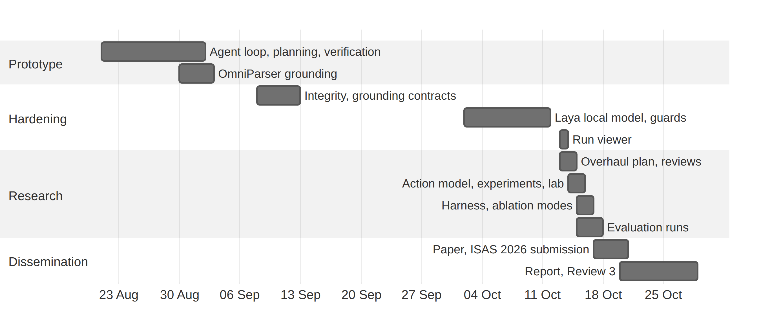
Figure 2.1 Project timeline (from the repository's commit history and evaluation logs)
Table 2.2 Project milestones
Period (2026) | Milestone | Outcome
21 Aug – 2 Sep | Prototype agent loop | Reusable action planning, action verification, hardened execution with verified downloads, OmniParser grounding
11 – 12 Sep | Evaluation integrity and grounding contracts | Strict task scoring, transition provenance, verified replay, refinement and capture-to-input checks
2 – 11 Oct | Local decision model | Laya as a fast local first-stage policy with completion, click and cascade guards; locale-aware date input
13 Oct | Run viewer and integrity fixes | Read-only web viewer; Gemini model pinned for reproducibility
13 – 15 Oct | Benchmark overhaul plan | Design plan reviewed and revised before implementation
15 Oct | Learned action model and benchmark | Scoped facts, action model, experiment phase, three-app lab, ground truth
15 – 17 Oct | Evaluation | Three memory modes × three seeds × 47 tasks, plus two ablations; the harness re-queues runs cut short by quota or network failures
17 Oct onwards | Dissemination | Paper written and submitted to ISAS 2026; this report; Review 3 on 28 Oct 2026

CHAPTER 3
TECHNICAL SPECIFICATION

3.1 REQUIREMENTS

3.1.1 Functional Requirements
Table 3.1 Functional requirements
ID | Requirement
FR1 | Accept a natural-language goal with a start URL (browser mode) or operate the visible desktop (desktop mode) from the command line.
FR2 | Capture a screenshot, and in a browser the page URL and viewport size, before every decision; never read the DOM, accessibility tree or an application API to find targets.
FR3 | Detect interactable controls and read their labels locally with OmniParser and RapidOCR, or with Gemini visual detection when selected (--grounder gemini).
FR4 | Decide from pixel contrast whether each control is enabled or disabled.
FR5 | Abstract each screen into section-scoped facts, keep a persistent inventory of facts and controls per section, and maintain a belief state during a run.
FR6 | Execute click, fill, select, set_checked, set_date, set_range, upload, set_color, press, scroll and done at pixel coordinates.
FR7 | Verify requested visual postconditions, and refuse done until every goal part is proven or declared unavailable.
FR8 | Learn effects, candidate preconditions and context conditions for each control and persist the model atomically as JSON.
FR9 | In active mode, run an experiment phase of replays, tours and ablated replays on a resettable application within a step budget and without LLM calls.
FR10 | Plan with learned schemas by backward chaining, navigate between sections, and declare a goal unavailable from the learned model.
FR11 | Support the memory modes none (no memory across runs), graph (state graph only), passive-action-model and active-action-model, and the two ablation modes; the evaluation compares none, passive and active.
FR12 | Log every transition with screenshots, timings and LLM calls by purpose to SQLite; export the state graph; report metrics.
FR13 | Provide a read-only local web viewer for runs, steps, the state graph and metrics.
FR14 | Serve the benchmark applications with reset and scoring endpoints hidden from the agent, and run the evaluation matrix in resumable shards.

3.1.2 Non-Functional Requirements
Table 3.2 Non-functional requirements
ID | Quality | Requirement
NFR1 | API independence | Target discovery uses only pixels and the URL; no application-specific selectors or coordinate scripts.
NFR2 | Reproducibility | The LLM is pinned to gemini-3.5-flash-lite; every result row records the commit, dirty flag, protocol, task-manifest version, model version and calls by purpose.
NFR3 | Cost efficiency | Learned steps and the experiment phase make no LLM calls; refinement is skipped for an unambiguous click.
NFR4 | Safety | High-impact actions are guarded; experiments run only on resettable lab applications; desktop mode keeps PyAutoGUI's fail-safe.
NFR5 | Robustness | Controls are identified by section and label, not position, so learned actions survive layout changes; a fact must be absent on two consecutive observations before it can end a run.
NFR6 | Reliability | Shared requests-per-minute and tokens-per-minute limits, rotation over API keys, and re-queueing of runs cut short by quota or network failures with memory restored.
NFR7 | Data integrity | Graph and model files are written atomically; the viewer opens databases read-only.
NFR8 | Privacy | The viewer binds to 127.0.0.1 by default; the documentation states that screenshots are sent to hosted Gemini.
NFR9 | Testability | Every component is covered by automated tests, including a real headless-Chromium end-to-end flow.

3.2 FEASIBILITY STUDY

3.2.1 Technical Feasibility
Every building block of the system already exists as mature software. Playwright and PyAutoGUI handle input, OmniParser and RapidOCR handle perception, and the Gemini API supplies multimodal reasoning, while SQLite, NetworkX and FastAPI cover storage, graphs and the web tools. The detector and the OCR both run on a laptop CPU, so no graphics accelerator is needed.
The real risks were the hosted model's rate limits and keeping long evaluation runs alive. A shared rate limiter and rotation across several API keys handled the per-minute limits; the daily limit was harder. Our ten Gemini keys allow about 5,000 calls a day and one seed of the evaluation needs about 2,000, so the quota ran out more than once. On one of those days Gemini's error named 00:00 UTC as the retry time and the harness slept until then; at that hour the quota was still gone, the next error named the following day, and the shards slept straight through the real reset at 12:30 IST (midnight Pacific time). The harness now sleeps in 15-minute chunks after a quota error and resumes as soon as one probe request is answered. Each of the three evaluation shards took 2 to 2.8 GB of RAM, and the out-of-memory killer stopped one roughly 15 times per seed; a supervisor script restarted them, and the harness re-ran interrupted tasks with their memory restored. The full evaluation, 423 main task runs plus two ablation sequences, ran to completion between 15 and 17 October 2026.

3.2.2 Economic Feasibility
The project bought no hardware and no licences. All the software is open source or free to use, the benchmark applications run locally, and we developed and evaluated everything on a laptop we already had. The one running cost that varies is the number of calls to the hosted LLM, and lowering it is one of our results: with the learned model and experiments, the agent needed 10.7 calls per task, about 36% fewer than the 16.7 needed without memory. The experiment phase itself makes no calls.

3.2.3 Social Feasibility
Screen-only automation reaches software that has no integration interface, such as legacy business programs and internal tools, and it can take over repetitive manual work in assistive use and in software testing. It also raises concerns. Screenshots may contain personal or confidential data, and they are sent to a hosted model; the documentation says so openly, and by default the run viewer listens only on the local machine. An agent acting on a real application could do harm, which is why high-impact actions are guarded and experiments run only on resettable sandboxes. The agent can also recognise and declare tasks the user is not allowed to perform, although Chapter 7 shows how limited that ability still is.

3.3 SYSTEM SPECIFICATION

3.3.1 Hardware Specification
Table 3.3 Hardware used for development and evaluation
Component | Specification
Processor | AMD Ryzen 7 7730U (8 cores, 16 threads)
Memory | 16 GB RAM
Graphics | Integrated AMD Radeon graphics (not used; detection and OCR run on the CPU)
Operating system | Fedora Linux 44 (KDE Plasma)
Network | Internet connection for the Gemini API
Display | A live graphical session for desktop mode and headed browser runs

3.3.2 Software Specification
Table 3.4 Software used (versions from the project's lock file; uv from uv --version)
Software | Version | Purpose
Python; uv | 3.12; 0.12.13 | Implementation language; dependency manager
Playwright with Chromium | 1.62.0 | Browser control, screenshots, mouse and keyboard input
PyAutoGUI | 0.9.54 | Desktop screenshots and input
OmniParser (git submodule) | YOLOv9 detector, refs/pr/37 | Detection of interactable regions
RapidOCR, ONNX Runtime | 3.9.2, 1.29.0 | Text recognition (PP-OCR models)
PyTorch, torchvision (CPU) | 2.13.0, 0.28.0 | Detector inference
google-genai | 2.18.1 | Gemini API client; model gemini-3.5-flash-lite
Laya | 0.3.23 | Local non-autoregressive decision model (System 1)
NetworkX, ImageHash, Pillow, NumPy | 3.6.1, 4.3.2, 12.3.0, 1.26.4 | State graph, image hashing, image processing
SQLite | Python standard library | Run and transition log, detection cache
FastAPI, Uvicorn, Jinja2 | 0.143.0, 0.54.0, 3.1.6 | Benchmark server and run viewer
unittest, pytest, Ruff | standard library, 9.1.1, – | Testing and static checks

CHAPTER 4
DESIGN APPROACH AND DETAILS

4.1 SYSTEM ARCHITECTURE
Figure 4.1 shows the architecture, a loop with four stages.
In the perception stage the agent captures the screenshot and URL, detects the controls and reads their labels locally, and uses pixel contrast to decide whether each control is enabled. When it is unsure which element a chosen target is, a Gemini call refines the choice on a crop. The knowledge stage turns the detections into facts scoped to the current section, keeps a persistent inventory of the facts and controls each section has shown, and updates the run's belief state. The learned action model lives in this stage, and the experiment phase refines it.
In the decision stage the planner looks for a plan in the learned model first. If it finds none, the local Laya model proposes an action, and Gemini takes over when Laya abstains, repeats itself or comes after a failed step. Once per task, a goal compiler (one Gemini call) turns the goal into a ledger of goal parts. The action stage carries out the decision with mouse and keyboard events, checks its effect and the goal parts, and records the transition. No learning component (blue) calls the LLM, and the agent touches the application it automates (dashed) only through pixels and input events.
There are three memory modes. With memory mode none, the state graph starts empty in every run and nothing carries over between runs. Passive mode learns the action model from the tasks it performs; active mode does the same and also runs the experiment phase once an application's exploration tasks are done. Memory is kept per application, so each application starts empty.
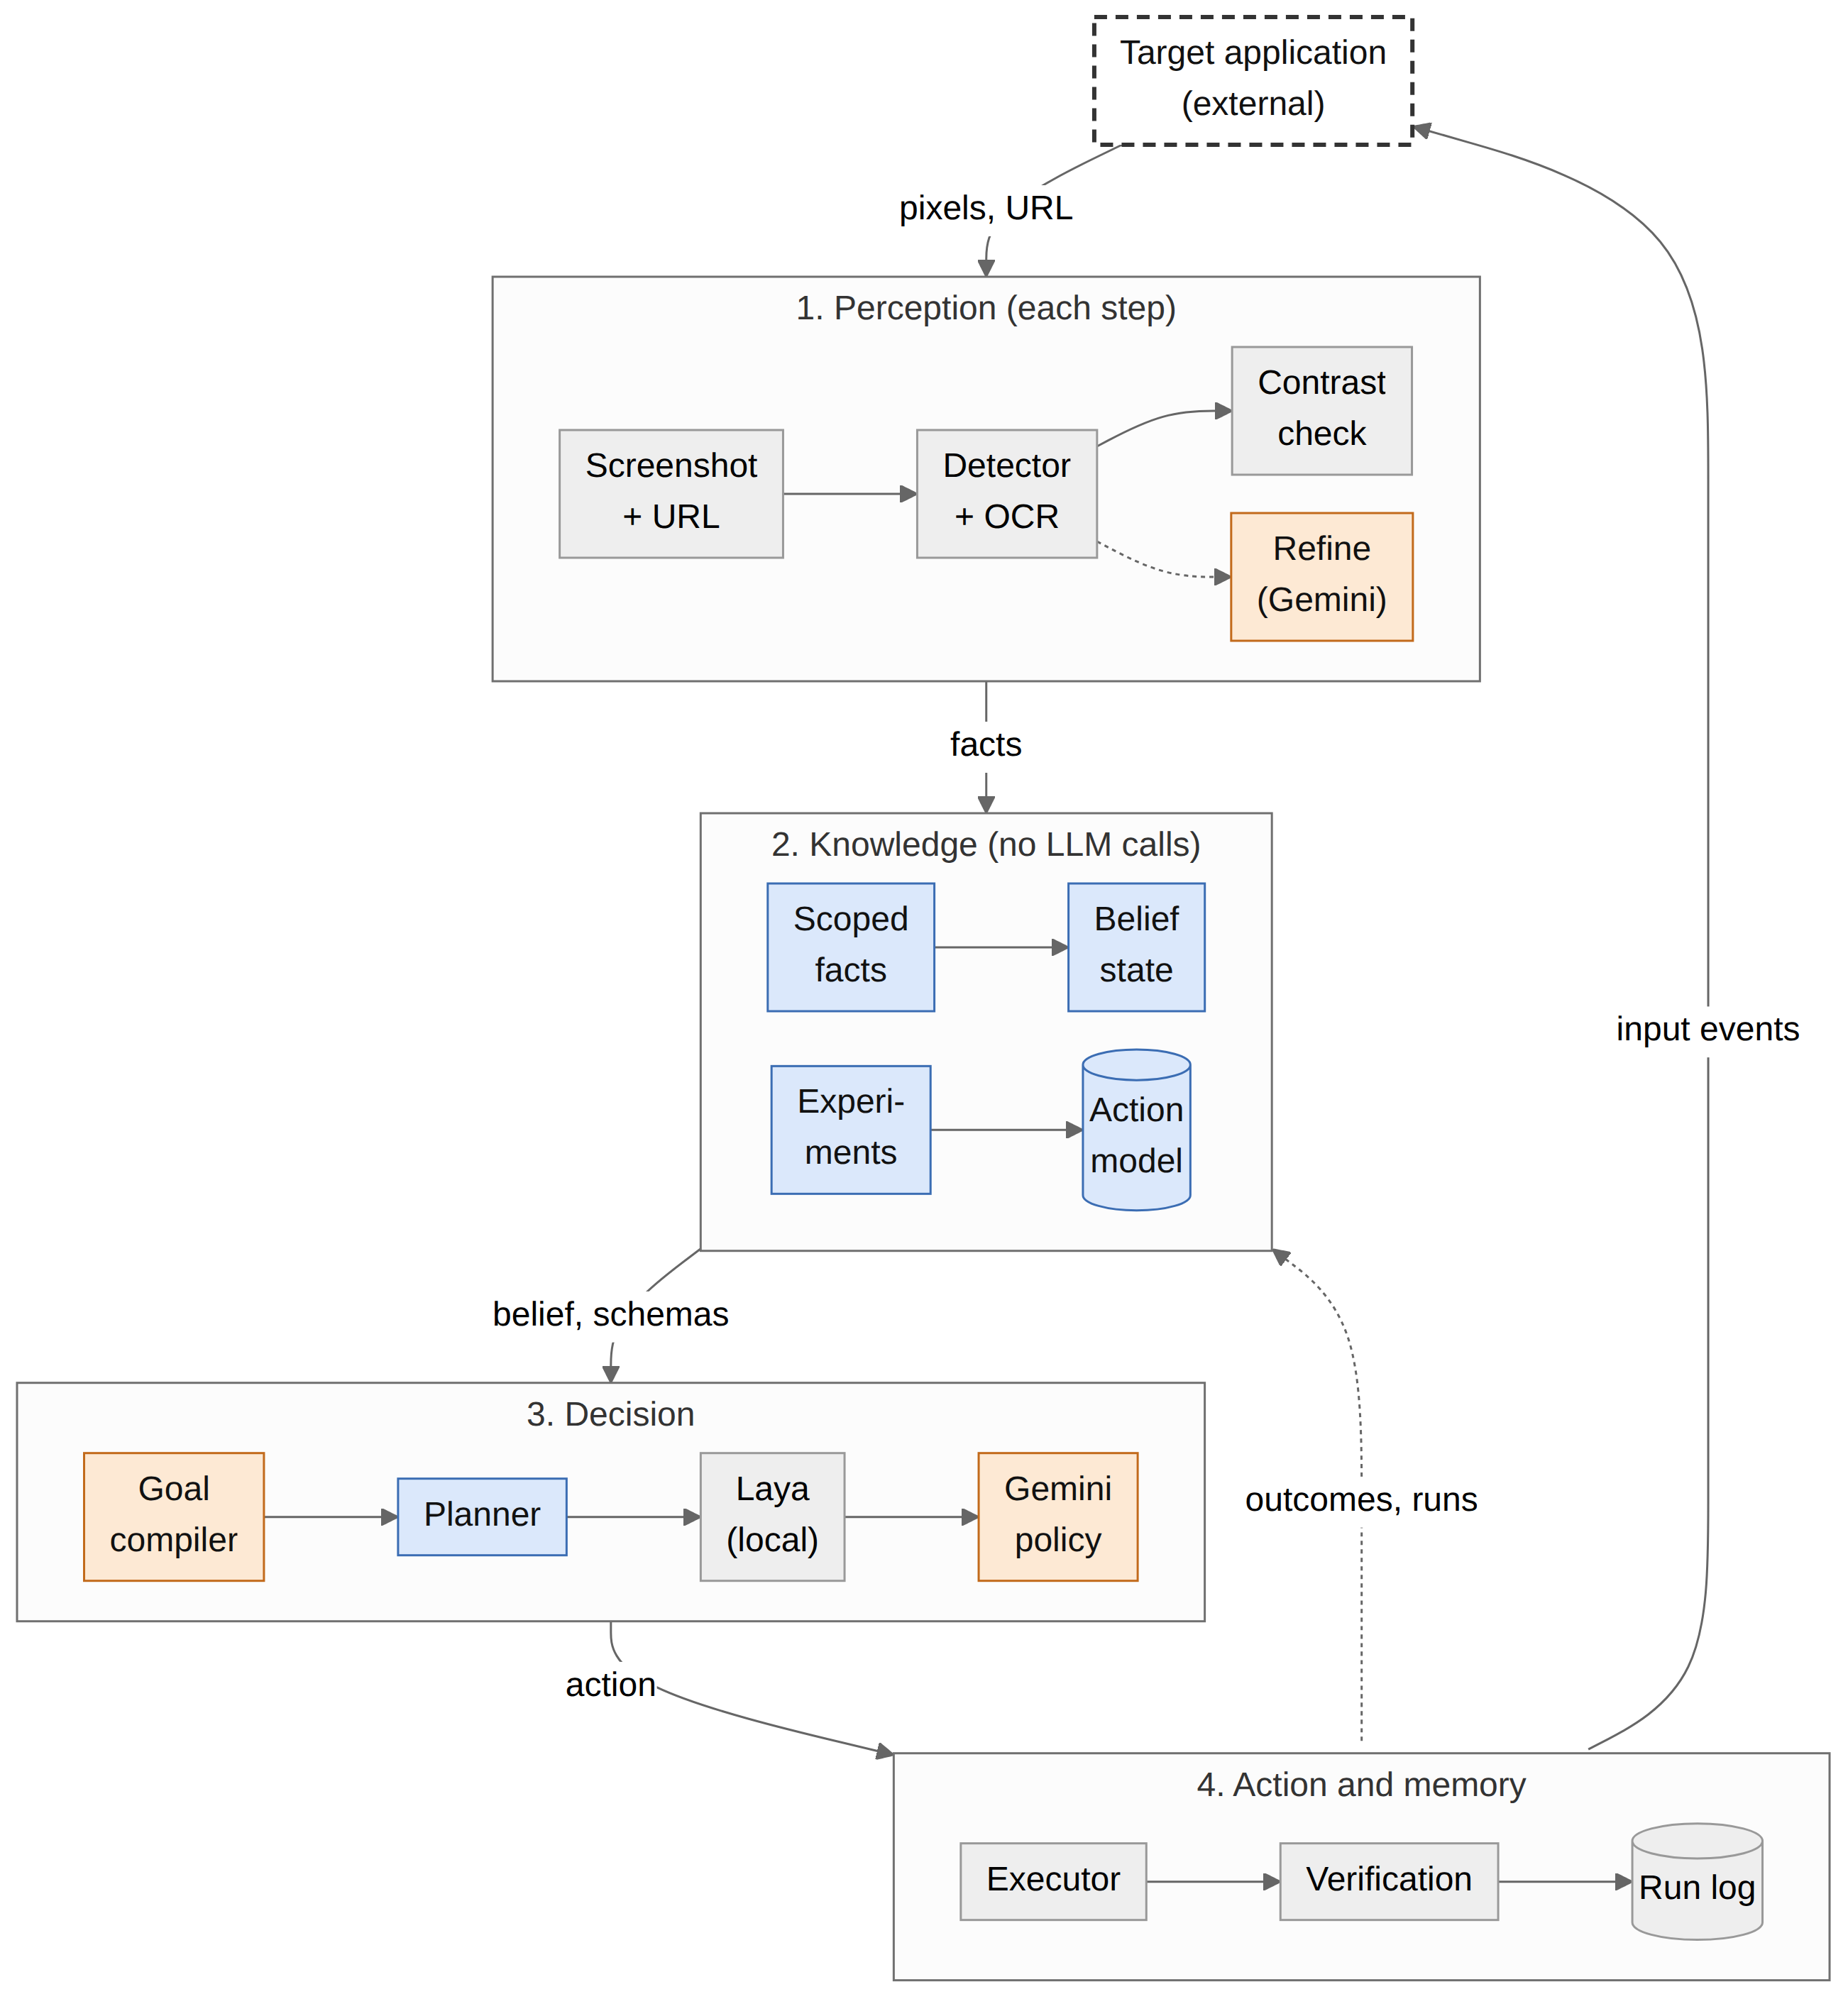
Figure 4.1 System architecture of the Vision GUI Agent (blue: learning components; orange: Gemini calls; grey: other local components; dashed: the external target application)

4.2 DESIGN

4.2.1 Data Flow Diagram
Figure 4.2 is the context-level data flow diagram. A goal goes in from the user and a result comes back. The target application supplies pixels and the URL and receives input events, while Gemini receives the numbered screenshot and the prompt and returns decisions. Everything recorded (the run log, screenshots, state graph and learned model) lands in the artifact store, which the run viewer reads.
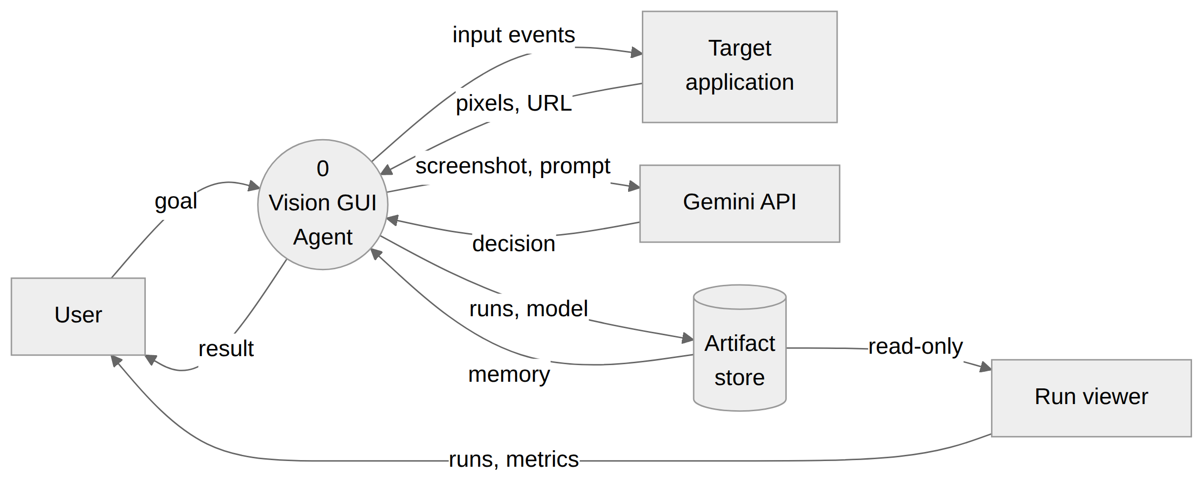
Figure 4.2 Data flow diagram, level 0 (context diagram)
Figure 4.3 breaks the agent into five processes. Capture (1.0) takes the screenshot. Grounding (2.0) detects controls and reads facts, consulting Gemini only for an uncertain target. Process 3.0 updates the belief state from the section inventory (D2) and writes learned rules to the action model (D1), process 4.0 plans from the learned schemas or asks the policy, and process 5.0 executes the action, verifies it, logs the transition to the run log (D3) and feeds the observed outcome back to learning.
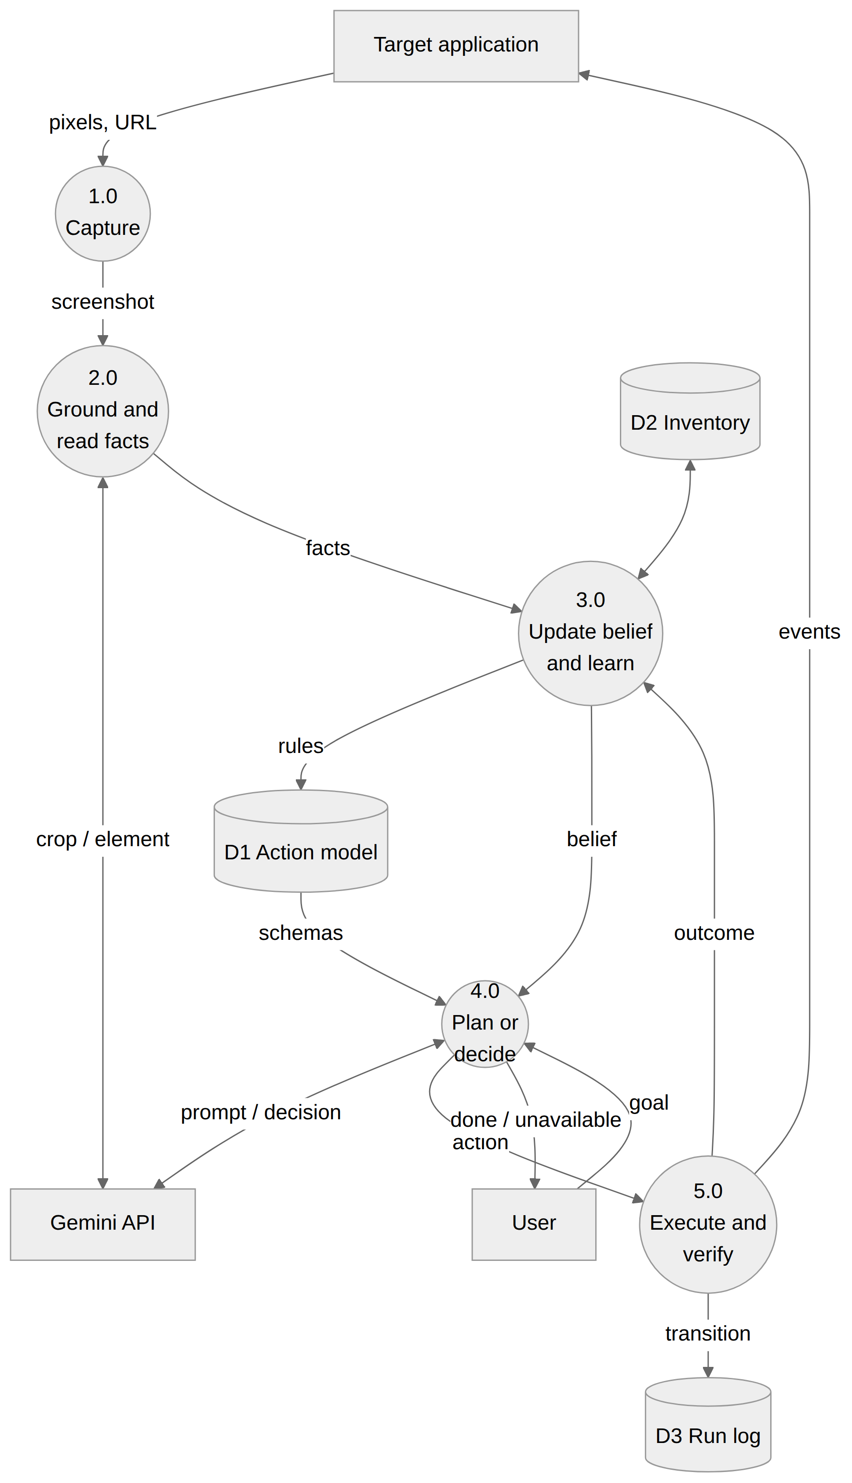
Figure 4.3 Data flow diagram, level 1

4.2.2 Use Case Diagram
In Figure 4.4, a user runs goals in a browser or on the desktop and looks at runs and metrics in the viewer. The researcher can also serve the benchmark applications, run the evaluation matrix (with the experiment phase in active mode), build the ground truth and run the calibration and benchmark checks. With a learning mode selected, running a goal always includes learning the action model, and it extends to declaring the goal unavailable when the learned model shows that the goal cannot be done.
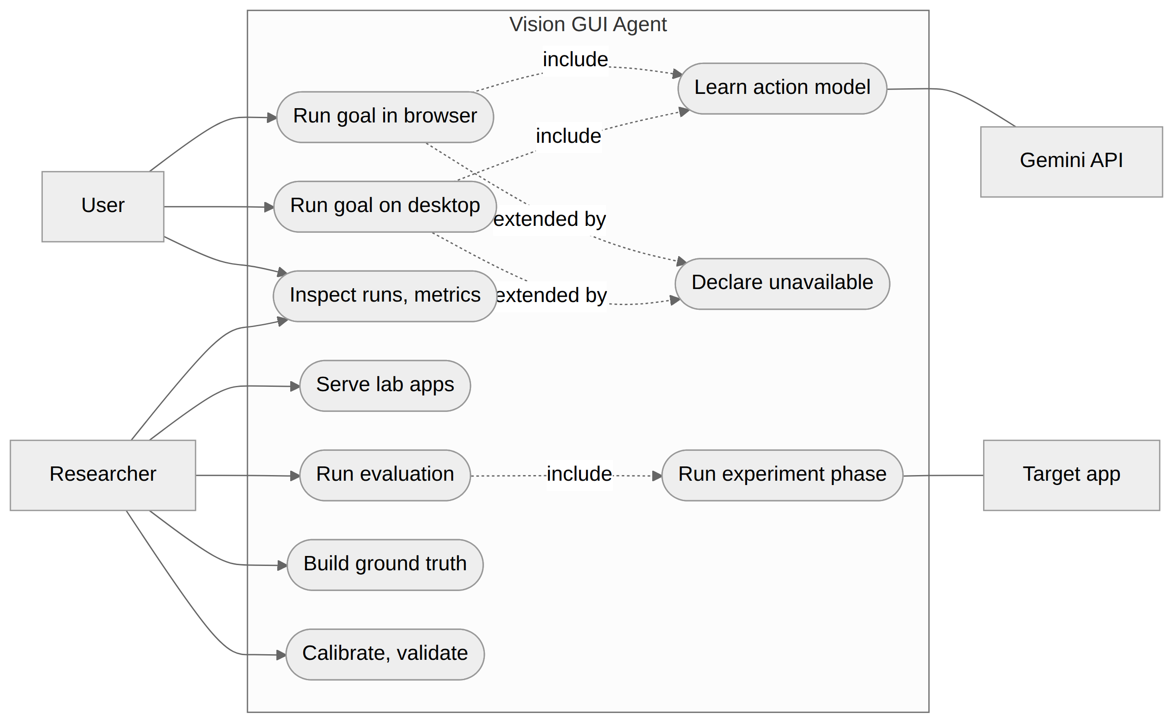
Figure 4.4 Use case diagram

4.2.3 Class Diagram
The main classes span two diagrams. Figure 4.5 covers the agent, its policies and perception: CascadingPolicy combines the local LayaPolicy with GeminiPolicy, OmniParserVisualGrounder and GeminiVisualGrounder both implement the VisualGrounder interface, and GeminiClientPool spreads requests across the configured API keys. Learning is in Figure 4.6. PredicateExtractor reads scoped facts with help from the Inventory, and BeliefState labels each fact. ActionModel holds one ActionSchema per control, each with its ActionEffect and ActionPrecondition records, FunctionalPlanner chains schemas together and ExperimentPhase refines the model.
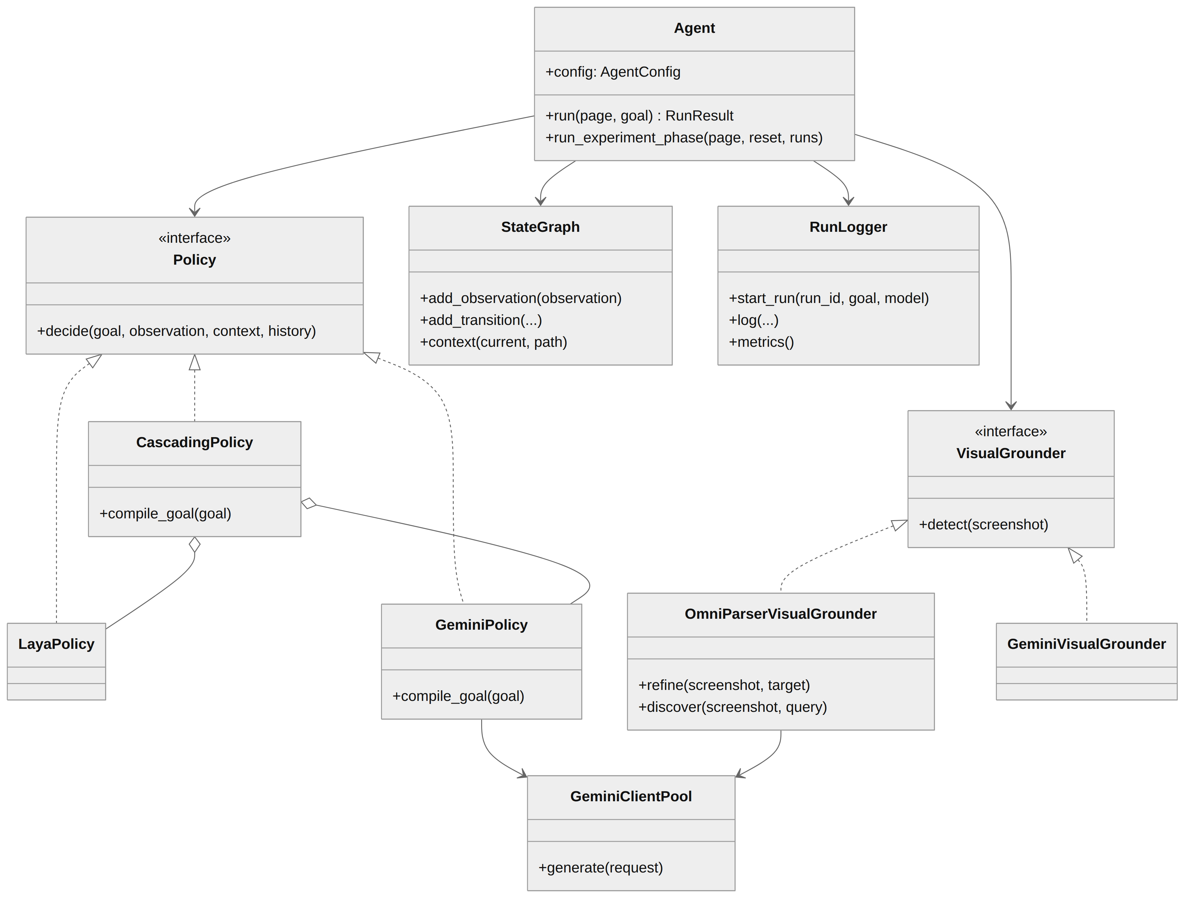
Figure 4.5 Class diagram: agent, policies and perception
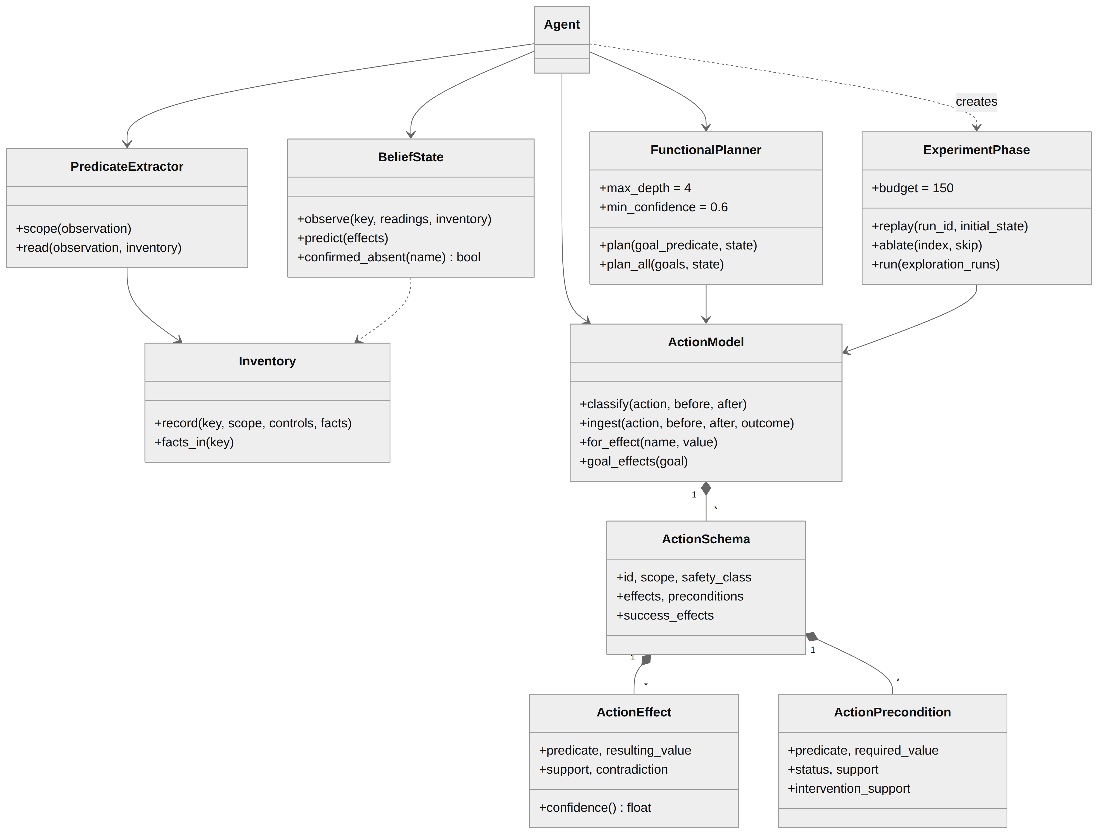
Figure 4.6 Class diagram: facts, belief state, action model, planner and experiment phase

4.2.4 Sequence Diagram
Figure 4.7 follows one task. The goal is compiled once, at the start. After that, each step captures the screen, perceives it, updates the belief state and asks the planner for a plan. If a learned plan exists, its next step runs with no LLM call. If a goal part matches a learned effect whose context condition has been missing on two observations in a row, the goal is declared unavailable. Otherwise the policy decides. Whichever path is taken, the outcome of the action is classified and fed into learning.
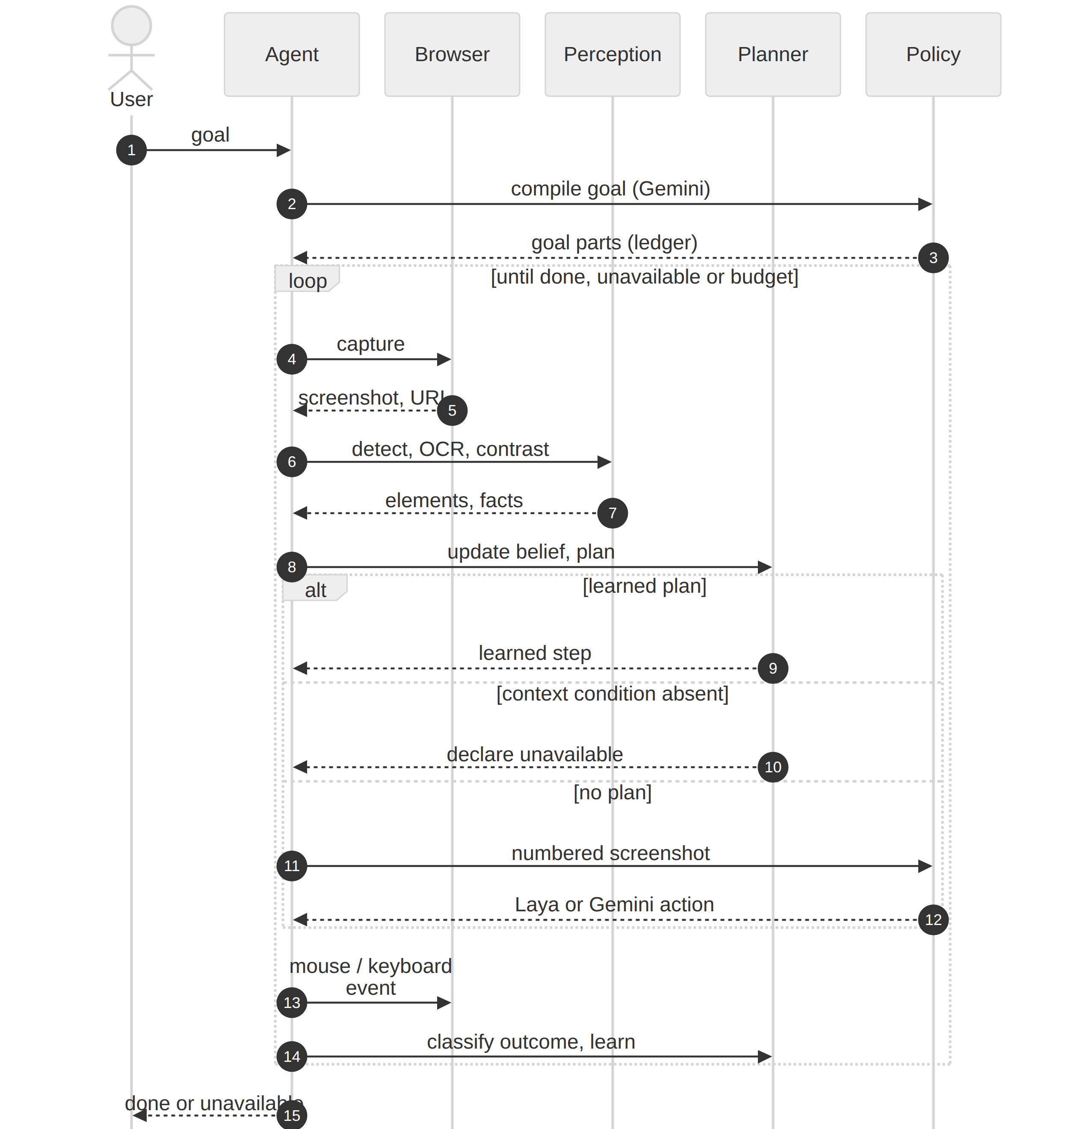
Figure 4.7 Sequence diagram of a task run

CHAPTER 5
METHODOLOGY AND TESTING

5.1 MODULE DESCRIPTION

5.1.1 Screen Capture and Perception
An observation is a screenshot plus, in a browser, the page URL and viewport size (capture.py). The default grounder (perception.py) finds interactable regions with the OmniParser YOLOv9 detector [4] and reads their labels and nearby text with RapidOCR, which uses PP-OCR models [29]. Whether a control is enabled is also decided from pixels. Inside the OCR word box, the agent takes the 5th and 95th luminance percentiles and computes the contrast ratio (L₉₅ + 0.05) / (L₅ + 0.05); below 3, the control is marked disabled, 3:1 being the WCAG 2.1 threshold for user-interface components [30]. We use percentiles because thin anti-aliased strokes pull the mean towards grey, and the ratio of the two extremes works for dark-on-light and light-on-dark text alike. Boxes smaller than 8 × 8 pixels are left unchanged.
When the policy picks a target whose identity is uncertain, a second Gemini call re-grounds it on a crop with the proposed box outlined (refinement). The policy itself sees a numbered Set-of-Mark screenshot [10], and if no detected element covers the intended target it can request a discovery call that searches the screenshot for it. Refinement is skipped for targets chosen by the learned model and for a click on the only enabled control with the cited label. We added the second exemption after a smoke run on 15 October 2026 in which about half of the Gemini calls only re-confirmed a target that the detector and OCR had already identified.

5.1.2 Scoped Facts and Belief State
A scope is an application section, identified by the URL path and a small allowlist of query keys (in the benchmark, just tab); scheme, host and port are ignored. Each scope has two kinds of Boolean fact (predicates.py). A status fact stands for one short visible status line such as “Launch brief.pdf is ready”. An availability fact available(c) is true when control c is shown and enabled. Fact names combine a hash of the scope with the normalised text, so the same text in two sections gives two facts. Page chrome is left out: status lines over about 60 characters, timestamps, and text or controls present in every section, such as the application title and section links.
A persistent inventory records every fact and control each scope has shown. During a run, the belief state labels each fact as observed, observed absent (known for the current scope but not on screen), predicted (by a learned effect), stale (last seen in another section) or unknown, and unknown facts count neither for nor against anything. An absence has to hold on two consecutive observations before the agent may use it to declare a goal unavailable, so a single OCR miss cannot end a run.

5.1.3 Learning the Action Model
A learned schema describes a click on one control, identified by its scope and normalised label (action_model.py, models.py). It holds effects (f, v) and preconditions (f, v), each with a support count s, a contradiction count k and confidence (s + 1) / (s + k + 2); an effect is confident at s ≥ 2 and confidence ≥ 0.6. After each click the agent compares the facts before and after it and classifies the outcome as in Table 5.1.
Table 5.1 Classification of a click's outcome
Outcome | Condition | What is learned
Effective | At least one confident effect of the action occurred | Changed facts support effects; facts that held before support candidate preconditions; a candidate that was false is contradicted
Provisional | Facts changed, but the action has no confident effect yet | Changed facts support effects; the execution is stored and credited to preconditions once an effect becomes confident
Ineffective | The action has confident effects and none occurred | Nothing, except inside an experiment, where exactly one fact was withheld
No change | No fact changed | Nothing

An appearing fact gives an effect directly. Disappearing facts need more care: one is credited only once some action is confident at making that fact appear, so the agent learns that a window closed without crediting every incidental disappearance. An action's own availability is never its own precondition. A status fact that no action ever changes, a role line for instance, becomes a context condition. And an effect that appears only in another section is credited when the agent returns there, provided exactly one action happened in between.

5.1.4 Experiment Phase
Passive learning turns every co-occurring fact into a candidate precondition. Active mode adds an experiment phase (experiment_phase.py) after an application's exploration tasks. The phase has its own 150-step budget, no goal and no policy, and it never calls the LLM. It resets the application to recorded start states and runs the three kinds of experiment shown in Figure 5.1.
- Reference replays. Each exploration run is replayed from its recorded start state. The page is reloaded after each replayed click, and only changes that survive the reload count. A click with a lasting change becomes a reference. Its changes become success effects, and its preconditions gain support.
- Tours. After a reference click, the agent visits sections showing a control it believes unavailable, so any change there is credited to that one action.
- Ablated replays. Each recorded run is replayed with one step left out, removing the facts that step produced. Every later action is then clicked directly, even if it looks disabled. If it still works, each removed fact is refuted as its precondition. If it fails while nothing else has diverged, the removed facts are confirmed together.
A precondition becomes required after at least two supporting observations, one or more of them an intervention, and no contradiction. One failed ablation plus one passive observation is enough.
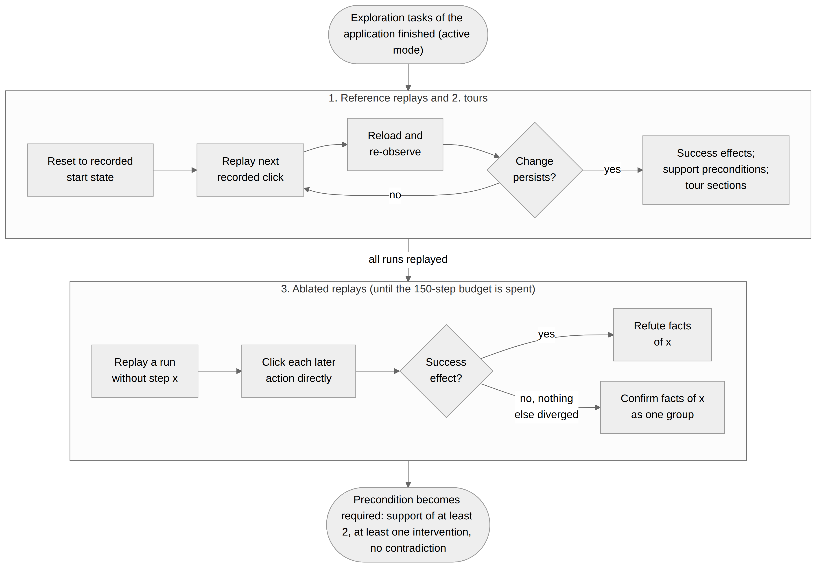
Figure 5.1 Experiment phase: reference replays, tours and ablated replays (no LLM calls)

5.1.5 Planning, Unavailability and Completion Checks
A goal is split into parts at “and”, “then”, commas and semicolons, and each part is matched to the learned effect it asks for. Only effects that make something appear can be goal targets.
A backward-chaining planner (functional_planner.py) then chains schemas, with depth 4 and confidence ≥ 0.6. It uses an action as it is if its control is believed available, makes a disabled or hidden control available through learned availability effects, and establishes required preconditions. It never establishes an unconfirmed candidate. That rule came from dry runs of the evaluation harness, where learned plans took side-effect steps. When the next schema is in another section, the agent clicks the learned link there. Learned steps make no LLM calls.
When the planner finds no plan, the agent declares the goal unavailable if a goal part matches the effect of a schema whose context condition (support ≥ 2) is observed absent on two consecutive observations.
The completion checks exist because Gemini kept stopping early. During testing on 15 October 2026 it ended “turn on notifications and save project approval with reviewers” as soon as notifications were on, and in one smoke run it ended “share the launch brief with the team” at step 0, citing the Documents link in the sidebar as evidence. Each goal part that the goal compiler leaves uncovered therefore becomes a constraint in the ledger, and done is refused until every part is proven or declared unavailable. A part is proven by clicking a control whose label contains the part's verb, if the click passes its check or produces new status text. The last open part may also be proven by the evidence of done itself, if that evidence appeared with the latest action that changed the screen. A control's own label never counts as that evidence.

5.1.6 Policy Cascade and Cost Accounting
When the learned model has no plan, the local Laya model proposes the next click (decision.py). Laya is a small non-autoregressive decision model run in-process. Gemini [31], pinned to gemini-3.5-flash-lite, decides when Laya abstains, repeats itself or follows a failed step. It receives the Set-of-Mark screenshot, the element list, the actions already taken from the current screen and the constraint ledger, and it runs at its default sampling temperature. The goal compiler runs at temperature 0, because at the default temperature the same goal compiled differently in each memory mode. GeminiClientPool rotates requests over the configured API keys and skips any key whose quota is exhausted, and a shared limiter enforces requests-per-minute and tokens-per-minute limits. Every LLM call is counted by purpose: policy, refinement, goal compilation or discovery.

5.1.7 Execution, Verification and Memory
The executor (executor.py) sends mouse and keyboard events at pixel coordinates, through Playwright in a browser or PyAutoGUI on the desktop (desktop.py). The default pixels mode uses no browser helpers; an explicit hybrid mode enables them for uploads, colour selection and verified downloads. Verification (verification.py) checks requested visual postconditions such as checked state and visible values, and a failed postcondition triggers one fresh observation before the plan is abandoned.
The state graph (state_graph.py) records screens and transitions. Two screens are the same state only if their normalised URL, functional control signature and exact pixels match, and remembered actions are re-grounded by their visible label and role before they run. Decisions from the learned model skip that re-grounding. Until late on 15 October 2026 they went through it, raw OmniParser elements failed the check, and the policy decided instead, so in every Gemini run the learned modes behaved exactly like the agent without memory. We fixed it before the evaluation runs began: learned decisions are now built from the current observation.
The run logger (logging_store.py) writes each transition to SQLite with its screenshots, timings (observe, model, execute and persist) and LLM calls by purpose. Graph and model files are written atomically.

5.1.8 Visual Function Lab and Evaluation Harness
The benchmark (visual_function_lab.py, visual_function_lab_server.py) has three locally served web applications (Table 5.2). Each has two hidden controls, two error-style controls and 7 to 11 disabled-style ones, along with controls that depend on the user's role or on earlier actions and effects that appear in other sections. Every application renders in three layouts (classic, compact and reordered) that move controls but never change their labels. A hidden evaluator keeps the application state the agent cannot see.
Table 5.2 Benchmark applications
App | Name shown on screen | Actions | Sections | Role in the evaluation
A | Acme Project Workspace | 15 | 5 (Overview, Documents, Data, Reports, Settings) | Explored, then tested
B | Northwind Support Desk | 11 | 4 (Queue, Escalations, Macros, Profile) | Explored, then tested
C | Harbor Supply Orders | 12 | 3 (Orders, Approvals, Shipping) | Not explored (RQ6)

Each agent has 47 tasks in six groups (Table 5.3), and a task's step budget is twice its scripted path length plus four. An achievable task passes when the final values of the scripted path hold and no other state changed. That second condition needed one correction before the evaluation: opening “Manage settings” on the way set a settings_open flag, so a run that had exported, archived and turned on notifications correctly was scored as failed. Flags that only record what the agent is looking at no longer count. An unavailable task passes when the agent declares it unavailable and changes nothing outside its setup.
Learned rules are scored against a ground truth (visible_truth.py) built by rendering every reachable section screen, 272 across the applications, and parsing each one with the agent's own perception, so the agent is never penalised for facts it cannot see. A copy baseline, which takes every fact true in any reachable state where the action works, gives a point of comparison.
Table 5.3 Task groups per agent
Group | Tasks | Content | RQ
Exploration | 8 | Four per learning application, covering every action of A and B | RQ1
Held-out | 8 | New goals over explored actions | RQ2
Composition | 6 | Goals with several parts, combining explored actions | RQ3
Layout shift | 8 | Four held-out and composition goals in the compact and reordered layouts | RQ4
Unavailable | 9 | One per application and style (hidden, disabled, error), impossible for the user's role | RQ5
Unseen application | 8 | Application C, in a fixed order, with no exploration phase | RQ6

The harness (evaluation.py) runs one sequence per memory mode and seed. For A and then B it runs the exploration tasks, the experiment phase (active mode only) and the remaining groups; on C it runs tasks C1 to C8 and then C's unavailable tasks. Results are appended per shard, so runs can resume; when the laptop was shut down mid-run on 16 October, the evaluation picked up from its results files the next afternoon. Memory is snapshotted before every run, and a run cut short by quota, network or service errors is re-run with its memory restored. Getting those error classes right took several fixes. Gemini's “499 CANCELLED”, for example, was at first counted as an agent failure and never re-queued.

5.1.9 Run Viewer
The viewer (vision_gui_agent/viewer) is a local, read-only web application. It lists runs with filters and shows each step with its decision screenshot, hoverable element boxes, the action, its outcome and a timing breakdown; it also draws the state graph and reports completion, latency, verification and decision-source metrics. Because it opens databases in SQLite read-only mode, it can stay open during a run.

5.2 TESTING

5.2.1 Automated Test Suite
The project has 337 automated tests in 26 modules, grouped by area in Table 5.4. One of them drives a real headless Chromium: the agent finds a button from screenshot pixels, clicks its visual centre, observes the result and closes the task without reading the DOM. Regression tests cover layout-shift recovery, semantic re-grounding, desktop input adaptation, persistence, safety constraints, the learning rules, the experiment phase, the evaluation harness and the viewer. On 20 October 2026 we ran the full suite with uv run python -m unittest discover -s tests, and all 337 tests passed in 327.7 seconds.
Table 5.4 Automated tests by area
Area | Test modules | Tests
Perception and grounding | availability, omniparser_grounder, refinement_diagnostics, semantic_coordinates, fresh_control_state, detection_cache | 30
Learning, experiments and ground truth | action_model, learning, experiment_phase, memory_modes, visible_truth | 75
Policy and goal completion | cascading_policy, laya_policy, scoped_constraints, visual_completion, model_request_boundaries, gemini_transport | 95
Agent core, execution and contracts | core, p0, p1, pixels_download, form_contract, artifact_serialization | 99
Evaluation harness and integrity | evaluation_harness, evaluation_integrity | 25
Run viewer | viewer | 13
Total | 26 modules | 337

5.2.2 Benchmark and Calibration Checks
Two more checks test the benchmark itself, independently of the agent. The symbolic check (vision-gui-benchmark) confirms that the evaluator's rules agree with the scripted path of every task in every layout; on 20 October 2026 it reported PASS for 117 task-layout runs covering 38 actions. The fixed-policy calibration (vision-gui-calibrate) runs the real screenshot, OCR and click loop with a scripted policy and no Gemini key. Its last recorded calibration runs, on 15 October 2026, all passed: 39 in the classic layout and 78 in the compact and reordered layouts.

5.2.3 Validation of the Disabled-Control Check
Before the evaluation we validated the pixel-contrast rule on labelled screenshots (Table 5.5). It never marked an enabled control as disabled, giving a precision of 1.00 on every set. On the lab fixture and benchmark applications it found all 37 disabled controls among 367, and among 240 controls styled with four CSS frameworks it found 102 of 114. Real software was harder. On 353 controls of a self-hosted Gitea instance it found 4 of 14 disabled controls and left 134 labels unread, and all 10 misses were the same control on 10 pages. Recall there was 0.29, against 1.00 on the benchmark.
Table 5.5 Disabled-control detection on labelled screenshots
Screenshot set | Controls | Disabled found | False alarms | Unread | Precision | Recall
Lab availability fixture | 70 | 4 of 4 | 0 | 0 | 1.00 | 1.00
Benchmark applications | 297 | 33 of 33 | 0 | 0 | 1.00 | 1.00
Four CSS frameworks | 240 | 102 of 114 | 0 | 6 | 1.00 | 0.89
Self-hosted Gitea | 353 | 4 of 14 | 0 | 134 | 1.00 | 0.29

5.2.4 Evaluation Protocol
We compared the three memory modes (none, passive and active, the last with a 150-step experiment budget) on the same 47 tasks, with the LLM pinned to gemini-3.5-flash-lite. Each mode ran three seeds with one run per task and seed, so 141 task runs per mode. Seeds 1 and 3 order the exploration tasks one way and seed 2 the reverse, and the LLM is sampled independently in every run. Success is reported with Wilson 95% intervals [32]. Modes are compared with exact McNemar tests on paired task runs and with exact sign-flip tests that take tasks or goals as units. Two ablations ran on application B with seed 1: passive mode without transition context in the prompt, and active mode with replay only (reference replays and tours, no ablated replays).

CHAPTER 6
PROJECT DEMONSTRATION
Every screenshot in this chapter comes from the project's own runs, either of the benchmark applications served locally or of steps recorded during the evaluation (active mode, seed 1).

6.1 RUNNING THE SYSTEM
Once the dependencies are installed, the commands below serve the benchmark applications locally, start the agent on a goal and open the viewer on the artifacts directory:
uv sync
uv run playwright install chromium
uv run visual-function-lab --port 4200
uv run vision-gui-agent http://127.0.0.1:4200/fullsuite \
"export the Launch Brief as PDF" --headed \
--memory-mode active-action-model --max-steps 20 --verbose
uv run vision-gui-viewer --artifacts artifacts --open
To control the visible desktop instead, run uv run vision-gui-agent --desktop followed by the goal.

6.2 BENCHMARK APPLICATIONS
Figure 6.1 shows application A in its classic layout. In Figure 6.2, application C is in the compact layout, where the section links move from a sidebar to a bar along the top and keep their labels. The agent identifies controls by section and label, so actions it learns in one layout carry over to the others.
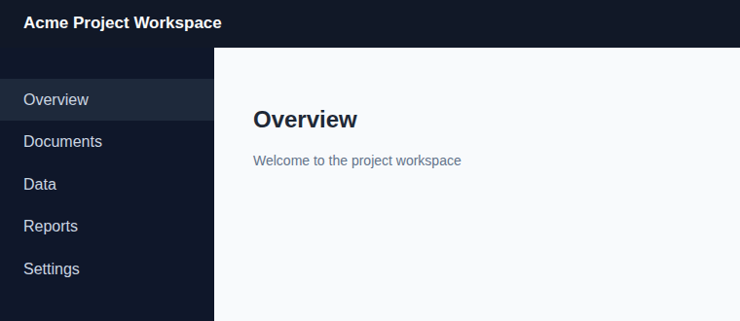
Figure 6.1 Application A (Acme Project Workspace), classic layout (cropped to the upper-left region)

Figure 6.2 Application C (Harbor Supply Orders), compact layout (cropped)

6.3 A COMPOSED TASK RUN FROM LEARNED STEPS
The goal “escalate ticket #4821 and save a reply macro” needs actions learned in different exploration tasks of application B. Figure 6.3 shows the first screen the way the agent sees it, with numbered Set-of-Mark boxes (red for actionable controls, blue for text), and Table 6.1 lists the recorded steps. In active mode the experiment phase had already made “Priority: urgent” a required precondition of escalating, so the planner begins by marking the ticket urgent. Apart from the goal compiler's single Gemini call, the whole task ran on learned steps and the local model. Passive mode and the agent without memory failed this goal in all nine of their runs.
We rehearsed the same goal live on 27 October 2026, starting from the model that active mode had learned in seed 1. It again took six learned steps and one LLM call. The run lasted about four minutes, most of it spent in local perception on the laptop's CPU.
Table 6.1 Recorded steps of the composed task (active mode, seed 1, classic layout)
Step | Decided by | Action | LLM calls
– | Goal compiler (Gemini) | Split the goal into its parts | 1
0 | Learned model | Click “Ticket #4821” | 0
1 | Learned model | Click “Mark urgent” (required precondition of escalating) | 0
2 | Section navigation | Open the Escalations section | 0
3 | Learned model | Click “Escalate #4821” | 0
4 | Section navigation | Open the Macros section | 0
5 | Learned model | Click “Save reply macro” | 0
6 | Laya (local) | Done, with “Saved replies” verified on screen | 0

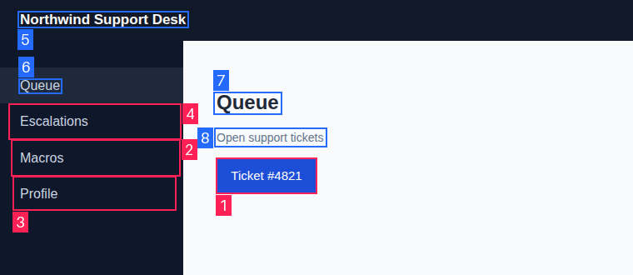
Figure 6.3 First step of the composed task: numbered screenshot of the Queue section (cropped)
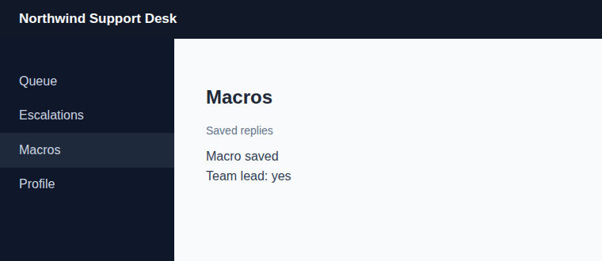
Figure 6.4 Final screen of the composed task: the macro is saved (cropped)

6.4 DECLARING A TASK UNAVAILABLE
In application B's disabled-style unavailable task the user lacks the approver role, so the ticket cannot be escalated. Figure 6.5 shows the Escalations section, with the button greyed out and the status line “Approver: no”. The agent opened the ticket using its learned model and reached Escalations with one policy call. It then declared the goal unavailable from the learned model and gave the missing context condition as its reason: “‘approver yes’ is shown whenever this works and is not shown now”. Two LLM calls, nothing changed, so the run passed.
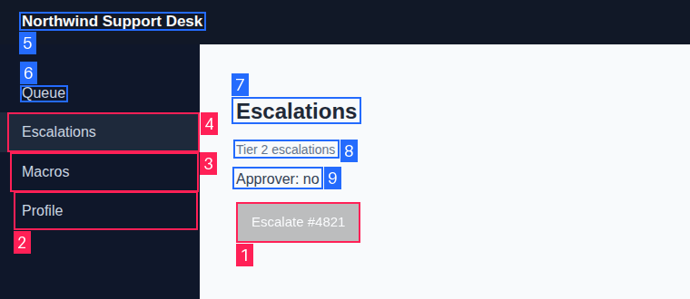
Figure 6.5 Unavailable task: the Escalate button is disabled and “Approver: no” is shown (cropped)

6.5 INSPECTING RUNS
Figure 6.6 shows the run viewer open on the composed task, with the steps and their verification status on the left and the decision screenshot with its numbered boxes on the right.
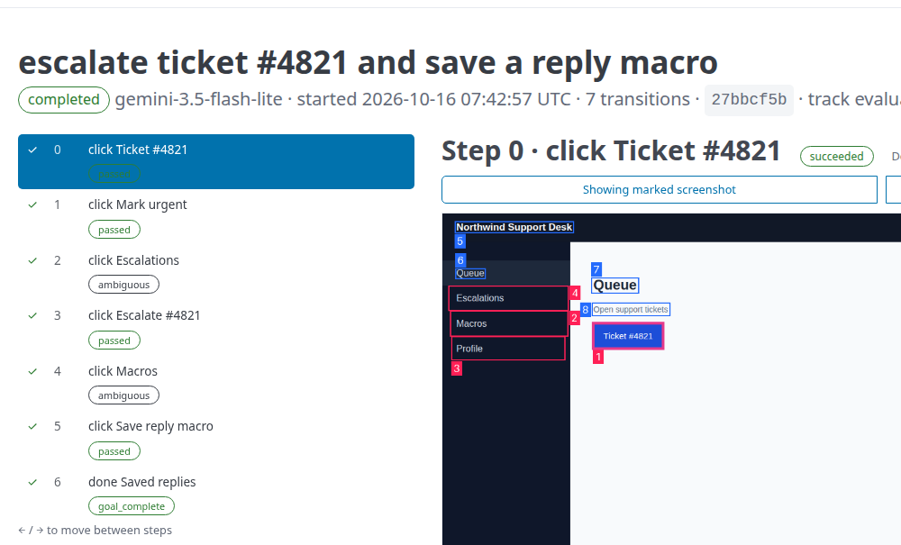
Figure 6.6 Run viewer showing the steps of the composed task (cropped to the step list and the decision screenshot)

CHAPTER 7
RESULT AND DISCUSSION

7.1 OVERALL RESULTS
Table 7.1 and Figure 7.1 summarise the evaluation. Over three seeds, active mode solved 74 of 141 task runs (52%), passive mode 54 (38%) and the agent without memory 38 (27%). The ranking held in every seed: 10, 13 and 15 of 47 tasks without memory, 18, 17 and 19 passive, and 26, 22 and 26 active.
Table 7.1 Success (solved/total task runs over three seeds, Wilson 95% interval in %) and mean LLM calls per task
Group | None | CI | Calls | Passive | CI | Calls | Active | CI | Calls
Exploration | 11/24 | 28–65 | 18.2 | 10/24 | 24–61 | 16.0 | 12/24 | 31–69 | 16.0
Held-out (RQ2) | 11/24 | 28–65 | 11.8 | 13/24 | 35–72 | 6.7 | 16/24 | 47–82 | 6.1
Composition (RQ3) | 2/18 | 3–33 | 26.2 | 4/18 | 9–45 | 14.9 | 10/18 | 34–75 | 14.2
Layout shift (RQ4) | 9/24 | 21–57 | 19.6 | 10/24 | 24–61 | 15.6 | 20/24 | 64–93 | 4.4
Unavailable (RQ5) | 0/27 | 0–12 | 10.7 | 9/27 | 19–52 | 8.3 | 9/27 | 19–52 | 8.4
Unseen app C (RQ6) | 5/24 | 9–40 | 16.7 | 8/24 | 18–53 | 13.9 | 7/24 | 15–49 | 16.4
All | 38/141 | 20–35 | 16.7 | 54/141 | 31–47 | 12.4 | 74/141 | 44–61 | 10.7

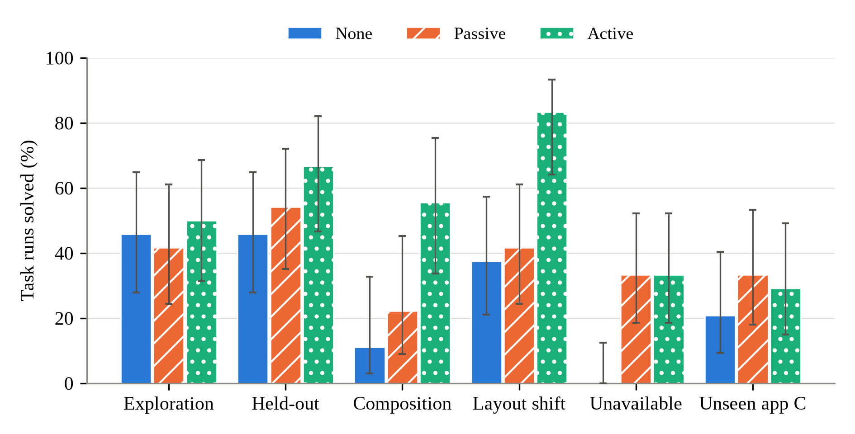
Figure 7.1 Success by task group and memory mode over three seeds, with Wilson 95% intervals (values in Table 7.1)
Over the 141 paired task runs, active mode solved 41 runs that the agent without memory failed and lost 5 (exact McNemar p < 0.001). Passive mode gained 23 and lost 7 (p = 0.005); active beat passive on 26 runs and lost 6 (p < 0.001). These p-values are optimistic, since the tests treat a goal's three seeds and layouts as independent. Counting each of the 47 tasks once (exact sign-flip test), the differences still hold for active versus none (p < 0.001), active versus passive (p = 0.008) and passive versus none (p = 0.04). With the layout variants of each goal grouped, active versus passive gives p = 0.06.
Before an application's experiment phase, and on application C, the two learning modes run identical code. There they differed on only 9 runs, 5 to 4, which gives a measure of run-to-run variation. Where the code differs, active mode won 18 runs and lost none on B and won 3 and lost 2 on A; outside B, both modes solved 27 of 87 runs. The gain of active over passive learning therefore comes mainly from one application. On B, active mode solved 47 of 54 runs with 5.4 calls per task, passive mode 27 with 10.0 calls and the agent without memory 17 with 14.7.

7.2 LEARNING FROM PIXELS (RQ1)
Table 7.2 compares the learned rules with the ground truth. Recall is computed over the actions each mode learned, and for this scoring an effect counts as confident at confidence ≥ 0.5. Effects are learned accurately: confident effects reach a precision of 0.93 to 1.00 in every seed. Passive precondition candidates are imprecise (mean precision 0.23 to 0.32), because every fact that happened to be on screen becomes one, though they are far better than the copy baseline (0.05 to 0.06).
Experiments raise precondition precision, but only for a few rules. On B, 9 of 14, 9 of 14 and 9 of 13 confirmed preconditions are correct in the three seeds (mean 0.66), with recall 0.80. On A the gain is small and inconsistent (mean 0.50 against 0.32 for passive candidates). On B the experiment phase ran all its planned ablated replays within 81 to 111 steps, while on A it used the whole 150-step budget, which probably contributes to the lower recall there. No experiment made an LLM call.
Table 7.2 Precision (P) and recall (R) of learned rules against the ground truth, mean over three seeds: confident effects (Eff.), candidate (Cand.) and experiment-confirmed (Conf.) preconditions, context conditions (Ctx.) and the copy baseline; recall is computed over the actions each mode learned, and effects count as confident at confidence ≥ 0.5 in this scoring
App, mode | Eff. P | Eff. R | Cand. P | Cand. R | Conf. P | Conf. R | Ctx. P | Ctx. R | Copy P
A, passive | .95 | .52 | .32 | .59 | – | – | .00 | .00 | .05
A, active | .97 | .69 | .26 | .86 | .50 | .30 | .00 | .00 | .05
B, passive | 1.00 | .31 | .23 | .40 | – | – | .13 | .17 | .06
B, active | 1.00 | .76 | .25 | .90 | .66 | .80 | .12 | .20 | .06

7.3 NEW GOALS, COMPOSITION AND LAYOUT SHIFT (RQ2–RQ4)
On held-out goals active mode solved 16 of 24 runs and passive mode 13, against 11 without memory, with 6.1 and 6.7 calls per task against 11.8. Some held-out tasks ran entirely on learned steps. “Assign ticket #4821 and reply to the customer” is one of them: in every seed, both learning modes completed it in three learned steps with two LLM calls, where the agent without memory needed five.
On composition tasks the agent without memory solved 2 of 18 runs, passive mode 4 and active mode 10. In every seed, and in both unseen layouts, active mode completed “escalate ticket #4821 and save a reply macro” with six learned steps and one LLM call (Section 6.3), and the other two modes failed it in all nine runs. In passive mode “Priority: urgent” stayed an unconfirmed candidate, which the planner does not establish.
Because controls are identified by normalised label rather than position, learned actions transfer to the unseen compact and reordered layouts. Active mode solved 20 of 24 layout-shift runs with 4.4 calls, passive mode 10 with 15.6 and the agent without memory 9 with 19.6. This is weaker evidence than it looks. Every shifted-layout run in active mode had the same outcome as the classic-layout run of the same goal and seed, so the gap to passive mode repeats the held-out and composition gaps and is not independent evidence.

7.4 KNOWING WHEN A TASK CANNOT BE DONE (RQ5)
No mode ever declared an achievable task unavailable. The agent without memory declared none of its 27 runs on impossible tasks unavailable. Each learning mode declared 9, the hidden, disabled and error styles on application B in every seed, each from the learned model with one or two LLM calls. These declarations cite permission lines, which are context conditions, and Table 7.2 shows that this rule class is imprecise overall. So the mechanism worked on B, but it is fragile, and no mode declared an impossible task on A or C. In 20 of the 81 runs on impossible tasks (11 of them without memory) the agent ended with done instead, sometimes after doing something else, such as exporting a document it was not allowed to share. The scorer counts these as failures.

7.5 AN APPLICATION WITHOUT EXPLORATION (RQ6)
On application C memory starts empty and there is no experiment phase, so passive and active mode run the same code (Table 7.3). Learning still made the second and third tasks cheaper. In every seed both learning modes solved the second task (“create an order, add an item and apply the discount”) with three LLM calls, while the agent without memory solved it in two of three seeds with 5.3 calls on average. Tasks C5 to C8 depend on approving and shipping orders, and no mode solved them in any seed.
Table 7.3 Application C, tasks in their fixed order: runs solved out of three seeds (mean LLM calls per run)
Mode | C1 | C2 | C3 | C4 | C5 | C6 | C7 | C8
None | 2 (10) | 2 (5) | 1 (7) | 0 (14) | 0 (24) | 0 (32) | 0 (15) | 0 (26)
Passive | 1 (10) | 3 (3) | 3 (5) | 1 (7) | 0 (24) | 0 (29) | 0 (8) | 0 (26)
Active | 2 (10) | 3 (3) | 2 (6) | 0 (9) | 0 (22) | 0 (33) | 0 (23) | 0 (25)

7.6 ABLATIONS
Table 7.4 shows the two ablations on application B with seed 1. Taking the transition context out of the prompt changed little: passive mode solved 9 of 18 tasks without it and 10 with it (p = 1.0). The slice is small, though. On it even passive mode against the agent without memory is not significant (6 won, 1 lost, p = 0.13), so a moderate effect of the context cannot be ruled out.
Removing the ablated replays erased all of active mode's lead. With replay only it solved 8 of 18 tasks against 17 (p = 0.004), no better than passive mode, and used 11.7 calls per task against 5.1. Reference replays alone learned effects as well as the full phase did, but by design they confirm no precondition, so the planner has none to establish; with this planner, the gain comes from the interventions. The replay-only phase also used just 21 of its 150 steps, against 95 for the full phase, so it does not show what an equally long interaction without interventions would yield.
Table 7.4 Ablations on application B, seed 1 (18 tasks)
Mode | Solved | Calls/task | Candidate P | Candidate R | Confirmed P | Effect R
None | 5/18 | 14.6 | – | – | – | –
Passive | 10/18 | 8.8 | .21 | .40 | – | .35
Passive without transition context | 9/18 | 9.9 | .27 | .40 | – | .35
Active | 17/18 | 5.1 | .24 | .90 | .64 | .72
Active with replay only | 8/18 | 11.7 | .20 | .90 | – | .82

7.7 COST ANALYSIS
With open-source software and hardware we already had, the project's running cost is mostly calls to the hosted LLM. Table 7.5 breaks them down by purpose over all 141 task runs per mode. Active mode needed 10.7 calls per task instead of 16.7, about 36% fewer, and 10.0 steps instead of 12.7, and the learned model decided 23% of its steps against 17% in passive mode. The saving comes from fewer policy and refinement calls, since the goal compiler costs one call per task in every mode.
Part of it simply follows from succeeding more often, because failed runs use up their step budget. On the 33 task runs that both active mode and the agent without memory solved, active mode used 4.9 calls against 8.7, and on the 62 that both failed it used 18.5 against 20.6. The experiment phase costs environment steps but no calls: 150 steps per seed on A, 81 to 111 on B.
Table 7.5 Mean LLM calls per task by purpose, steps per task and share of steps decided by the learned model (141 task runs per mode)
Measure | None | Passive | Active
Policy calls | 13.1 | 9.8 | 8.3
Refinement calls | 2.0 | 1.2 | 1.1
Goal compilation calls | 1.0 | 1.0 | 1.0
Discovery calls | 0.5 | 0.3 | 0.4
Total LLM calls | 16.7 | 12.4 | 10.7
Steps | 12.7 | 10.8 | 10.0
Steps decided by the learned model | 0% | 17% | 23%

7.8 DISCUSSION AND LIMITATIONS
The results back the project's main idea. An agent that sees only pixels can learn an explicit model of an application, and that model makes later tasks more successful and cheaper.
The evidence has limits. We built the benchmark applications for this study, and they show state through explicit status and permission lines, which real applications do less consistently; the low recall of the disabled-control check on Gitea is one sign of that. The model only holds outcomes the agent has seen. Exploration on application A never generated a report, so neither learning mode could plan that goal, and A and C would gain most from directed exploration of untried controls. The learning modes also differ from the agent without memory in more than the action model, since they see transitions from earlier runs in the prompt and active mode spends extra environment steps on experiments. Still, over all seeds, 11 of passive mode's 23 wins and 16 of active mode's 41 wins over the agent without memory used no policy call, so the prompt context cannot directly explain them. Lenient completion checks let some runs stop early, but the outcome-based scorer counts that as a failure, so it cannot inflate the success rates. And the experiment phase needs resettable start states.
With three seeds and a sampling LLM, only the difference between active mode and the agent without memory, and the results on B, are clearly separated under every test. The gain of active over passive learning rests on a few goals of one application.

CHAPTER 8
CONCLUSION
We built an API-independent GUI agent that discovers the states and behaviour of an unfamiliar application from its pixels. It perceives only screenshots and the page URL, acts only through mouse and keyboard events, and learns, for every control it uses, which facts the control changes and which facts it needs. An experiment phase replays the agent's own runs with steps ablated, without calling the LLM, and this raises the precision of the learned preconditions. A planner then runs learned actions directly. The same model lets the agent declare some impossible tasks unavailable and stops the LLM from ending multi-part tasks too early.
On a benchmark of three applications with 47 tasks per agent, over three seeds, the agent with experiments solved 52% of task runs, compared with 38% for passive learning and 27% without memory, and it needed 10.7 LLM calls per task instead of 16.7. It reused learned actions in new combinations and in unseen layouts, solving 20 of 24 layout-shift runs where the agent without memory solved 9. Learned effects reached a precision of 0.93 to 1.00. Most of the gain over passive learning came from one of the three applications, and on that application an experiment phase without ablated replays did no better than passive learning. For that application, seed and planner, the gain depends on the interventions.
All the objectives in Section 2.3 were met. We implemented the agent, the learning and experiment methods, the planner and unavailability checks, the benchmark with its ground truth and the supporting tools, covered them with 337 automated tests and evaluated them. A research paper on the work has been submitted to ISAS 2026 and is under review.
As future work, we want to test the agent on real self-hosted applications against memory baselines such as workflow memory and exploration notes. We also plan to add directed exploration of controls that have never been clicked, run the ablations on every application and seed, and learn actions other than clicks, such as text entry.

CHAPTER 9
REFERENCES
[1] B. Zheng, B. Gou, J. Kil, H. Sun, and Y. Su, "GPT-4V(ision) is a generalist web agent, if grounded," in Proc. 41st Int. Conf. Machine Learning (ICML), PMLR, vol. 235, 2024, pp. 61349–61385.
[2] W. Hong et al., "CogAgent: A visual language model for GUI agents," in Proc. IEEE/CVF Conf. Computer Vision and Pattern Recognition (CVPR), 2024, pp. 14281–14290.
[3] K. Cheng, Q. Sun, Y. Chu, F. Xu, L. YanTao, J. Zhang, and Z. Wu, "SeeClick: Harnessing GUI grounding for advanced visual GUI agents," in Proc. 62nd Annu. Meeting Assoc. Computational Linguistics (ACL), 2024, pp. 9313–9332, doi: 10.18653/v1/2024.acl-long.505.
[4] Y. Lu, J. Yang, Y. Shen, and A. Awadallah, "OmniParser for pure vision based GUI agent," arXiv:2408.00203, 2024.
[5] S. Zhou et al., "WebArena: A realistic web environment for building autonomous agents," in Proc. Int. Conf. Learning Representations (ICLR), 2024. [Online]. Available: https://arxiv.org/abs/2307.13854
[6] J. Y. Koh, R. Lo, L. Jang et al., "VisualWebArena: Evaluating multimodal agents on realistic visual web tasks," in Proc. 62nd Annu. Meeting Assoc. Computational Linguistics (ACL), 2024. [Online]. Available: https://arxiv.org/abs/2401.13649
[7] X. Deng, Y. Gu et al., "Mind2Web: Towards a generalist agent for the web," in Advances in Neural Information Processing Systems (NeurIPS), Datasets and Benchmarks Track, 2023. [Online]. Available: https://arxiv.org/abs/2306.06070
[8] T. Xie et al., "OSWorld: Benchmarking multimodal agents for open-ended tasks in real computer environments," in Advances in Neural Information Processing Systems (NeurIPS), 2024. [Online]. Available: https://arxiv.org/abs/2404.07972
[9] S. Yao, J. Zhao, D. Yu, N. Du, I. Shafran, K. Narasimhan, and Y. Cao, "ReAct: Synergizing reasoning and acting in language models," in Proc. Int. Conf. Learning Representations (ICLR), 2023. [Online]. Available: https://arxiv.org/abs/2210.03629
[10] J. Yang et al., "Set-of-Mark prompting unleashes extraordinary visual grounding in GPT-4V," arXiv:2310.11441, 2023.
[11] C. Zhang et al., "UFO: A UI-focused agent for Windows OS interaction," arXiv:2402.07939, 2024.
[12] C. Zhang, Z. Yang, J. Liu, Y. Han, X. Chen, Z. Huang et al., "AppAgent: Multimodal agents as smartphone users," arXiv:2312.13771, 2023.
[13] H. Wen, Y. Li, G. Liu et al., "AutoDroid: LLM-powered task automation in Android," in Proc. 30th Annu. Int. Conf. Mobile Computing and Networking (MobiCom), 2024. [Online]. Available: https://arxiv.org/abs/2308.15272
[14] S. Lee et al., "MobileGPT: Augmenting LLM with human-like app memory for mobile task automation," arXiv:2312.03003, 2023.
[15] Z. Z. Wang, J. Mao, D. Fried, and G. Neubig, "Agent workflow memory," in Proc. 42nd Int. Conf. Machine Learning (ICML), PMLR, vol. 267, 2025, pp. 63897–63911.
[16] G. Wang et al., "Voyager: An open-ended embodied agent with large language models," Transactions on Machine Learning Research, 2024.
[17] A. Memon, I. Banerjee, and A. Nagarajan, "GUI ripping: Reverse engineering of graphical user interfaces for testing," in Proc. 10th Working Conf. Reverse Engineering (WCRE), 2003.
[18] T. Su et al., "Guided, stochastic model-based GUI testing of Android apps," in Proc. 11th Joint Meeting on Foundations of Software Engineering (ESEC/FSE), 2017, pp. 245–256, doi: 10.1145/3106237.3106298.
[19] Y. Gu, B. Zheng et al., "Is your LLM secretly a world model of the Internet? Model-based planning for web agents," Transactions on Machine Learning Research, 2025.
[20] H. Chae et al., "Web agents with world models: Learning and leveraging environment dynamics in web navigation," in Proc. Int. Conf. Learning Representations (ICLR), 2025. [Online]. Available: https://arxiv.org/abs/2410.13232
[21] H. Tang, D. Key, and K. Ellis, "WorldCoder, a model-based LLM agent: Building world models by writing code and interacting with the environment," in Advances in Neural Information Processing Systems (NeurIPS), 2024. [Online]. Available: https://arxiv.org/abs/2402.12275
[22] L. Guan, K. Valmeekam, S. Sreedharan, and S. Kambhampati, "Leveraging pre-trained large language models to construct and utilize world models for model-based task planning," in Advances in Neural Information Processing Systems (NeurIPS), 2023. [Online]. Available: https://arxiv.org/abs/2305.14909
[23] Q. Yang, K. Wu, and Y. Jiang, "Learning action models from plan examples using weighted MAX-SAT," Artificial Intelligence, vol. 171, no. 2–3, pp. 107–143, 2007.
[24] S. N. Cresswell, T. L. McCluskey, and M. M. West, "Acquiring planning domain models using LOCM," The Knowledge Engineering Review, vol. 28, no. 2, pp. 195–213, 2013, doi: 10.1017/S0269888912000422.
[25] D. Aineto, S. Jiménez Celorrio, and E. Onaindia, "Learning action models with minimal observability," Artificial Intelligence, vol. 275, pp. 104–137, 2019, doi: 10.1016/j.artint.2019.05.003.
[26] B. Juba, H. S. Le, and R. Stern, "Safe learning of lifted action models," in Proc. 18th Int. Conf. Principles of Knowledge Representation and Reasoning (KR), 2021, pp. 379–389.
[27] L. Lamanna, A. Saetti, L. Serafini, A. Gerevini, and P. Traverso, "Online learning of action models for PDDL planning," in Proc. 30th Int. Joint Conf. Artificial Intelligence (IJCAI), 2021, pp. 4112–4118, doi: 10.24963/ijcai.2021/566.
[28] P. Verma, S. R. Marpally, and S. Srivastava, "Asking the right questions: Learning interpretable action models through query answering," in Proc. AAAI Conf. Artificial Intelligence, vol. 35, no. 13, 2021, pp. 12024–12033, doi: 10.1609/aaai.v35i13.17428.
[29] Y. Du et al., "PP-OCR: A practical ultra lightweight OCR system," arXiv:2009.09941, 2020.
[30] W3C, "Web Content Accessibility Guidelines (WCAG) 2.1," W3C Recommendation, 2018. [Online]. Available: https://www.w3.org/TR/WCAG21/
[31] Gemini Team, "Gemini: A family of highly capable multimodal models," arXiv:2312.11805, 2023.
[32] E. B. Wilson, "Probable inference, the law of succession, and statistical inference," Journal of the American Statistical Association, vol. 22, no. 158, pp. 209–212, 1927, doi: 10.1080/01621459.1927.10502953.

APPENDIX A – SAMPLE CODE
The listings below are taken unchanged from the project's source code. They show the pixel-contrast check that decides whether a control is disabled, the code that classifies the outcome of a click, and the backward-chaining planner.

A.1 Disabled-control check (vision_gui_agent/perception.py)
def label_contrast(image: Image.Image, box: tuple[float, float, float, float]) -> float | None:
"""WCAG contrast between a text box's glyph cores and its background.

Uses the 5th and 95th luminance percentiles rather than means: strokes are
1-1.5 px wide, so averages are pulled toward grey by anti-aliasing. Taking
the ratio of the two extremes makes no assumption about text polarity.
Returns None for boxes too small to measure.
"""
import numpy as np
left, top, right, bottom = (int(round(value)) for value in box)
left, top = max(0, left), max(0, top)
right, bottom = min(image.width, right), min(image.height, bottom)
if right - left < 8 or bottom - top < 8: return None
luminance = _relative_luminance(np.asarray(image.crop((left, top, right, bottom)).convert("RGB")).reshape(-1, 3))
low, high = np.percentile(luminance, [5, 95])
return float((high + .05) / (low + .05))

A.2 Classifying a click's outcome (vision_gui_agent/action_model.py)
def classify(self, action: SemanticAction, before: State, after: State, probe: bool = False) -> OutcomeClass:
before_values, after_values = _values(before), _values(after)
changes = changes_between(before_values, after_values)
schema = self.schemas.get(self._schema_id(action))
if probe:
success = set(schema.success_effects) if schema else set()
return "effective" if any(f"{name}={json.dumps(value)}" in success for name, value in changes.items()) else "ineffective"
if not changes: return "no_change"
confident = [effect for effect in (schema.effects if schema else ()) if self.is_confident(effect) and self._applicable(effect, before_values)]
if not confident: return "provisional"
if len(self._groups(confident)) > 1:
# Confident effects never seen together from this kind of state (e.g. an
# error message and the real result): judging between them would be a guess.
return "provisional"
return "effective" if any(after_values.get(effect.predicate) == effect.resulting_value for effect in confident) else "ineffective"

A.3 Backward chaining over learned schemas (vision_gui_agent/functional_planner.py)
def _establish(self, target: str, value: object, state: dict[str, object], depth: int,
visiting: set[tuple[str, object]], forbidden: frozenset[tuple[str, object]]) -> tuple[list[ActionSchema], dict[str, object]] | None:
key = target, value
if depth >= self.max_depth or key in visiting: return None
choices = []
for schema in self.model.for_effect(target, value, self.min_confidence):
effects = [effect for effect in schema.effects if effect.confidence >= self.min_confidence]
if any((effect.predicate, effect.resulting_value) in forbidden for effect in effects): continue
branch = dict(state)
needs = self._needs(schema, branch)
if needs is None: continue
chain: list[ActionSchema] = []
valid = True
for predicate, required in needs:
if (predicate, required) == key or branch.get(predicate) == required: continue
established = self._establish(predicate, required, branch, depth + 1, visiting | {key}, forbidden)
if established is None: valid = False; break
steps, branch = established
chain.extend(steps)
if not valid: continue
for effect in effects:
branch[effect.predicate] = effect.resulting_value
plan = chain + [schema]
confidence = min((effect.confidence for item in plan for effect in item.effects), default=0)
risk = sum(item.safety_class == "high_impact_or_irreversible" for item in plan)
choices.append(((risk, len(plan), -confidence), plan, branch))
if not choices: return None
_, plan, final_state = min(choices, key=lambda item: item[0])
return plan, final_state

